

CS3343 Software Design

Test Report

Group 12

|  |  |  |
| --- | --- | --- |
| Name | Student ID | Title |
| CHENG Yin | 56614557 | Project Manager |
| SONG Tao | 56642520 | Assistant Project Manager |
| LUO Peiyuan | 56642728 | Programmer |
| ZHOU Junchen | 56641511 | Programmer |
| DU Wenxi | 56643530 | Tester |
| FENG Yong | 56642741 | Tester |

Table of Contents

1. Testing Module Organization 3

2. Testing Strategy 3

3. Unit Test Cases Analysis 5

**3.1 TimeSlots.java** 5

**3.2 TablesManagement.java** 12

**3.3 ManualClock.java** 15

**3.4 AccountManagement.java** 15

**3.5 Dish.java** 18

**3.6 Customer.java** 18

4. Integration Test 19

**4.1 White-Box Testing** 19

**4.1.1 Login Module** 19

**4.1.2 Admin Module** 21

**4.1.3 Customer Module** 23

**4.1.4 Merchant Module** 30

**4.1.5 Table Management** 32

**4.1.6 Table Arrangement Algorithms** 35

**4.2 Black-Box Testing** 41

**4.2.1 Sample Test Cases** 41

**4.2.2 Invalid Input** 43

5. System Test 44

**5.1 Testing Approach** 44

**5.2 Test Cases for System Testing** 45

**5.2.1 Customer** 45

**5.2.2 Merchant** 53

**5.2.3 Admin** 59

**5.3 Sample Bug Report** 70

**Issue #C1** 70

**Issue #M1** 71

**1. Testing Module Organization**

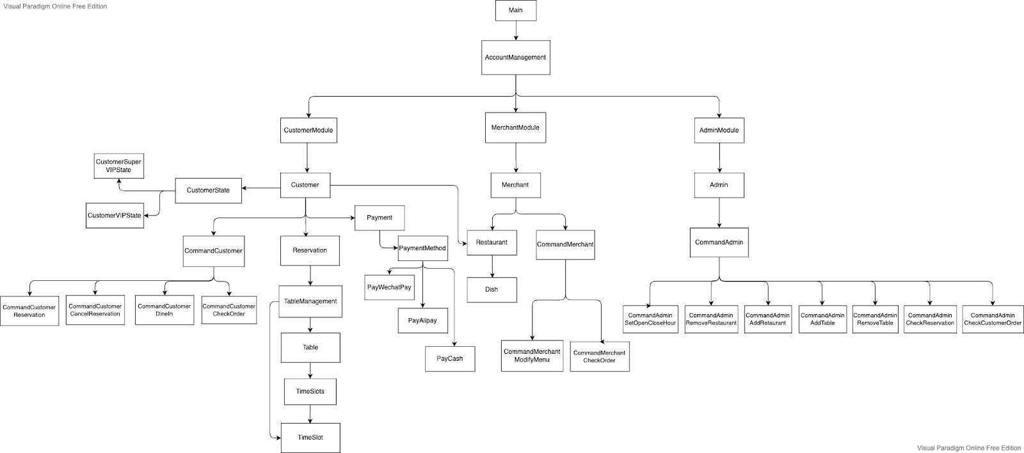

The diagram describes the testing structure of our GoGoEat system. There are three important modules under the Main and AccountManagement module, which are the Customer module, Merchant module, and Admin module.

**2. Testing Strategy**

We were programming and testing simultaneously with the V-model development process. As soon as we got the user requirement and architecture, we started black box testing design. Then coming to the detailed design, we did unit testing when unit codes were done and did integration testing when branches were defined. With this process, we achieved saving time and improved the project code quality.

In this project, we used multiple testing strategies as listed below:

1. Bottom-Up Approach
2. Black-box Testing

Due to the wide scope, it is difficult to express our system into a tree structure, so the bottom-up approach and white-box testing are insufficient. We also test some significant units apart from the bottom parts of units to increase the CC/DC coverage. Apart from white-box testing, black-box testing is also used in integration testing and system testing.

**2.1 Bottom-up testing**

Bottom-up testing is a specific type of integration testing that tests the lowest components of a code base first. More generally, it refers to a middle phase in software testing that involves taking integrated code units and testing them together before testing an entire system or code base.

To conclude our test coverage, we achieved more than 50% of the coverage for both unit and integration testing, testing all the methods except those for printing purposes only.

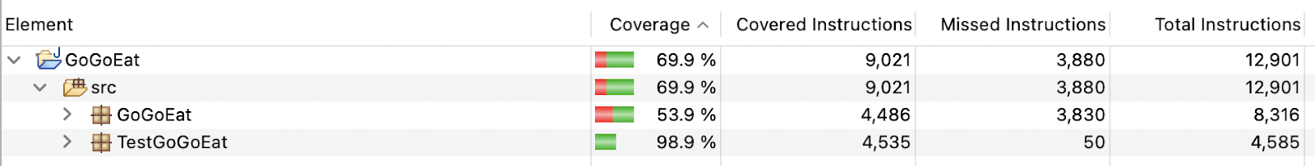

The black-box testing approach, which will be introduced later, will cover the remaining test cases together with inputting and outputting.

**2.2 Black-box Testing**

Due to the broad scope of the project and the massiveness of the test scenarios, we used the black-box testing to provide the minimum test cases that would cover most of the test scenarios.

* **Default Value Strategy:**

The default value strategy determines a default value for each parameter, starts the test with a test case in which all parameters take default values, varies one parameter from its default value after each test, and repeats the above step until every value of every parameter has appeared in the tests at least once.

* **Category-Partition Method (CPM)**

The Category-Partition Method (CPM) required us to analyze the specification to identify the individual testable function units, parameters of the function units, and entities in the environment; classify the specifications into categories and partition the categories into choices; determine the constraints among the choices; write the test specification, and express them in Test Specification Language (TSL); evaluate the output of each test frame, and convert the test frames into test cases.

**3. Unit Test Cases Analysis**

**3.1 TimeSlots.java**

Branch Coverage:

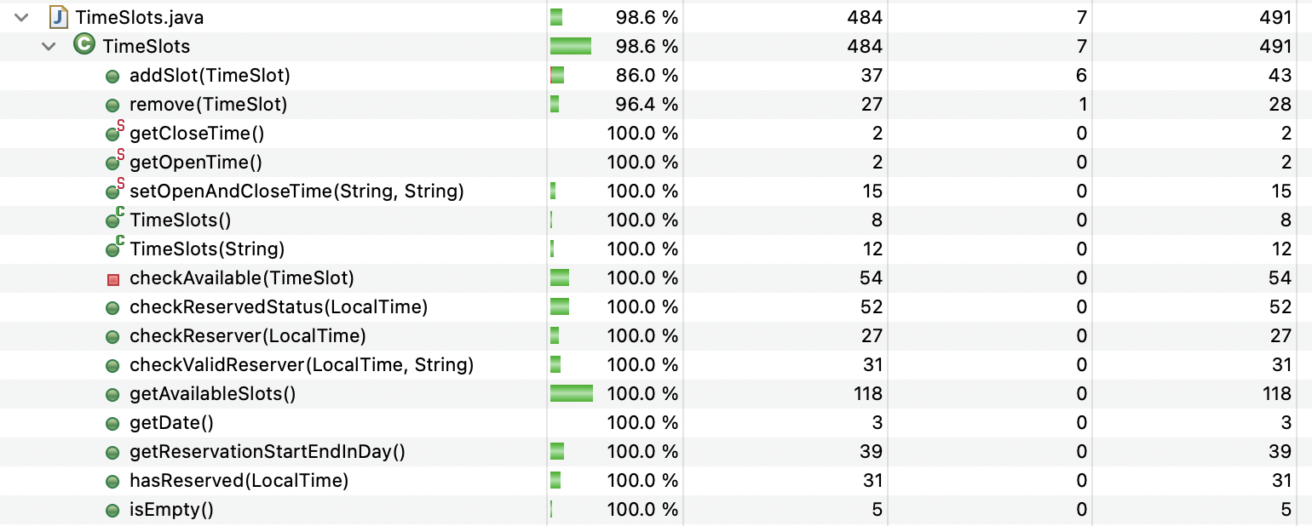

**Test 1**

Purpose: To check whether the function ***setOpenAndCloseTime()*** can successfully set the time limit of the time slot if the user wants to add a timeslot in the future.

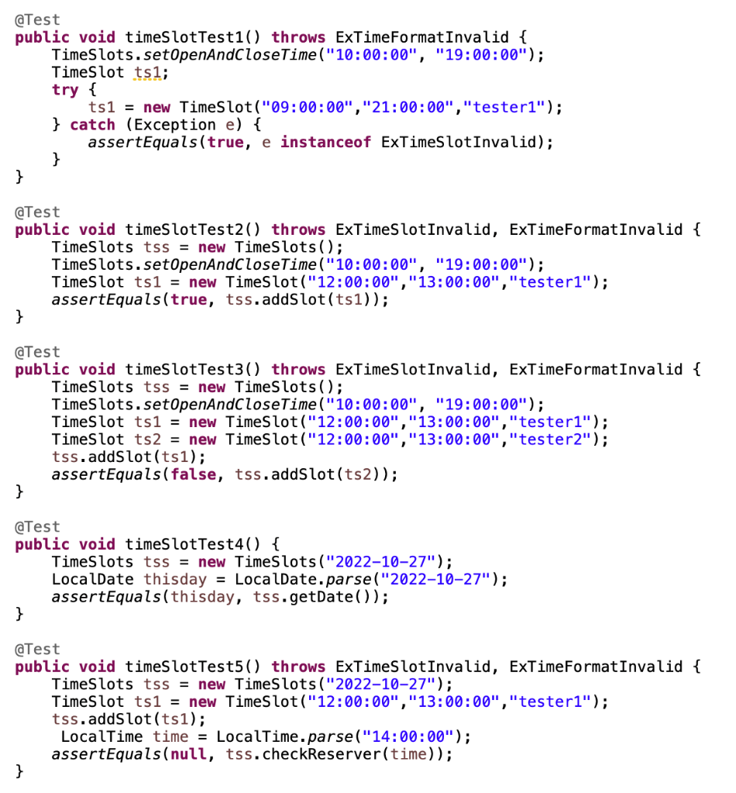

**Test 2**

Purpose: Check the function ***addSlot()*** can successfully add a new slot into the timeslots ArrayList or not.

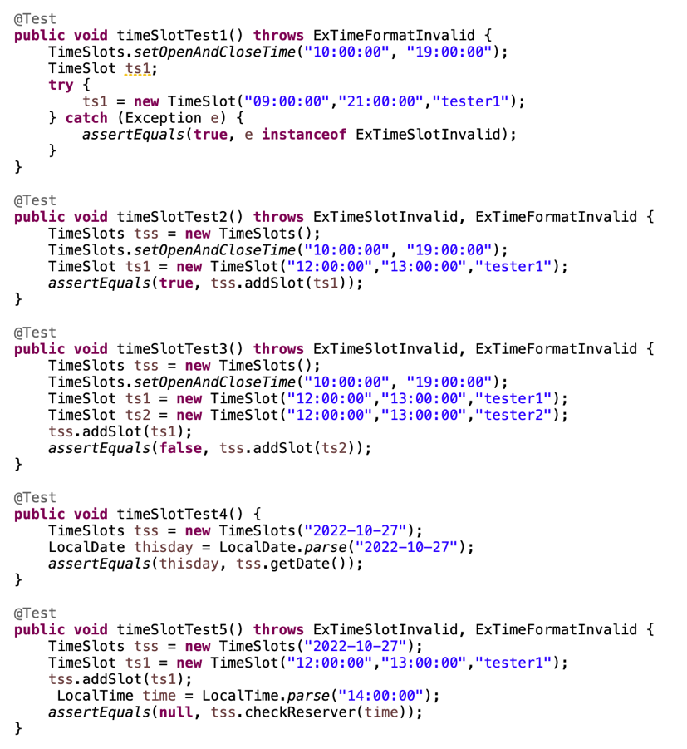

**Test 3**

Purpose: Check the function ***addSlot()*** can prevent adding duplicate timeslot or not.

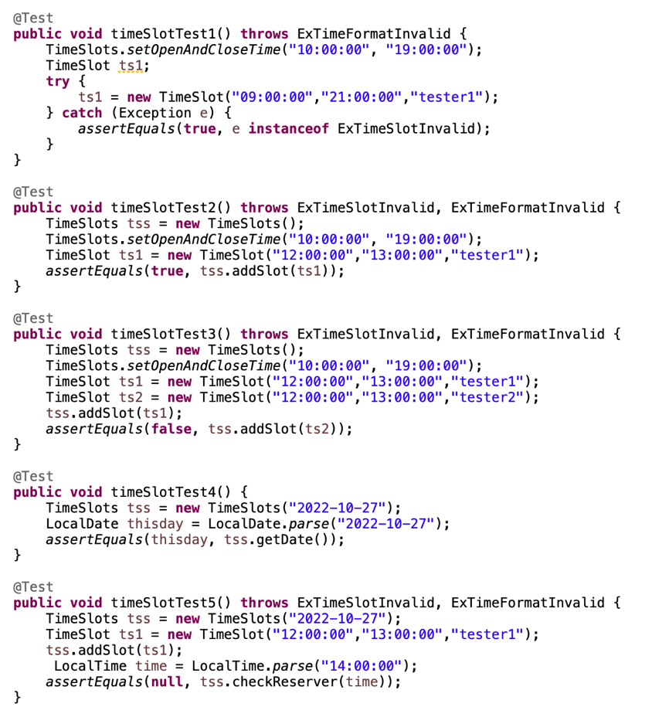

**Test 4**

Purpose: To check whether the function ***getDate()*** can successfully output the correct date that the user has set before.

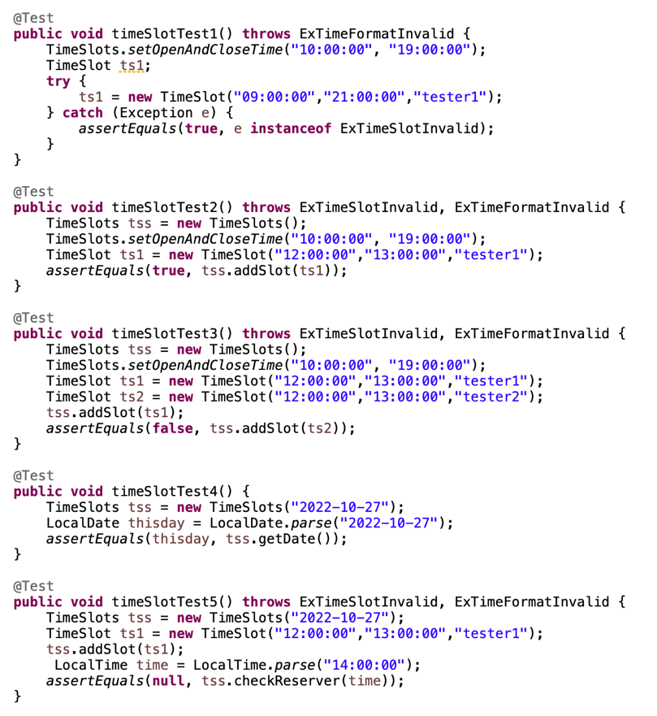

**Test 5**

Purpose: To check whether the function ***checkReserver()*** can successfully output the correct reservation owner number if the timeslot has been reserved before.

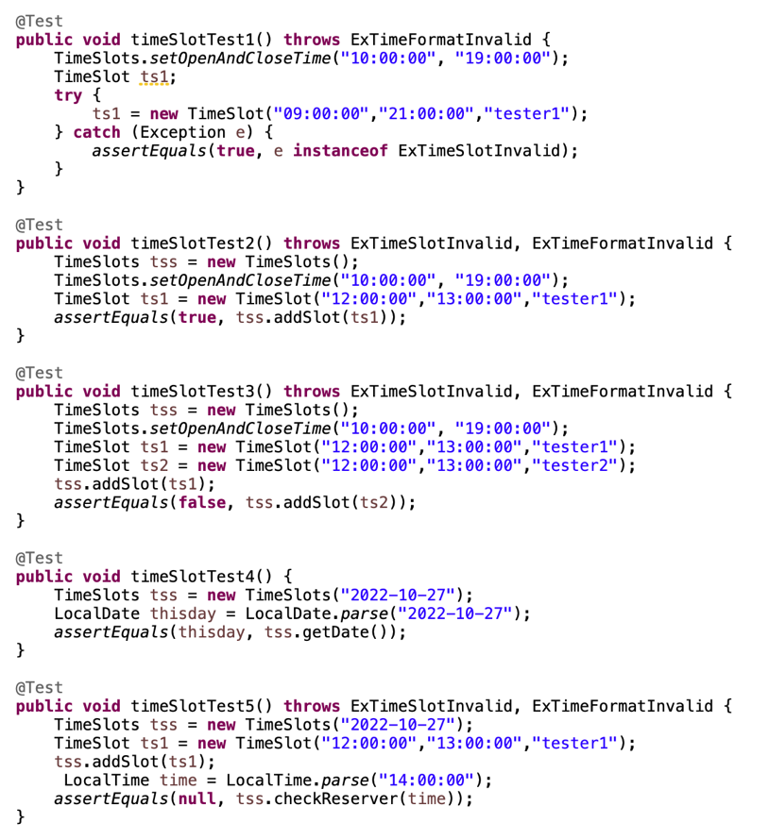

**Test 6**

Purpose: To check whether the function ***checkReserver()*** can successfully output the null result if the timeslot has not been reserved before.

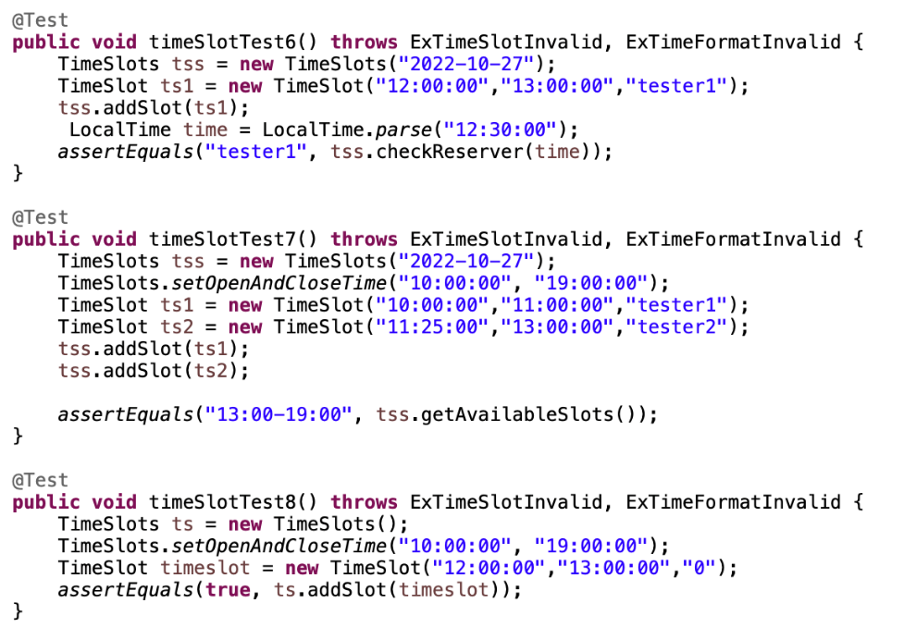

**Test 7**

Purpose: To check whether the function ***getAvailableSlots()*** can output the correct timeslot when some slots are unavailable or have been booked.

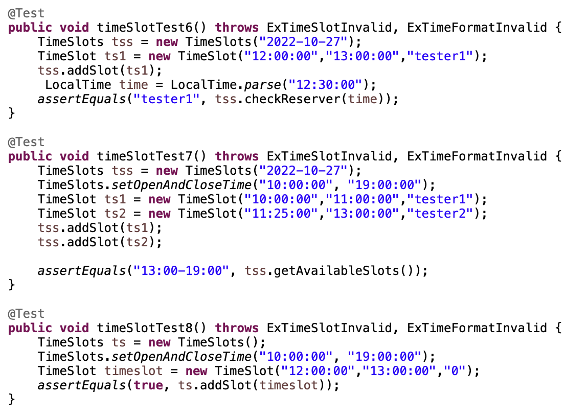

**Test 8**

Purpose: To check whether the function ***remove()*** can successfully delete the reserved timeslot.

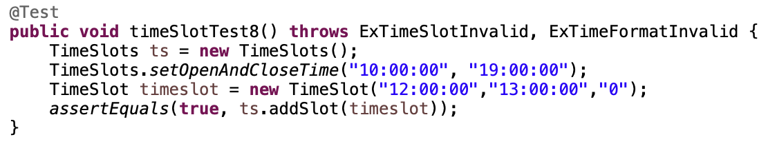

**Test 9**

Purpose: Using a ***LocalTime*** as a variable to check the function ***hasReserved()*** can successfully identify whether a time point has been booked or not.

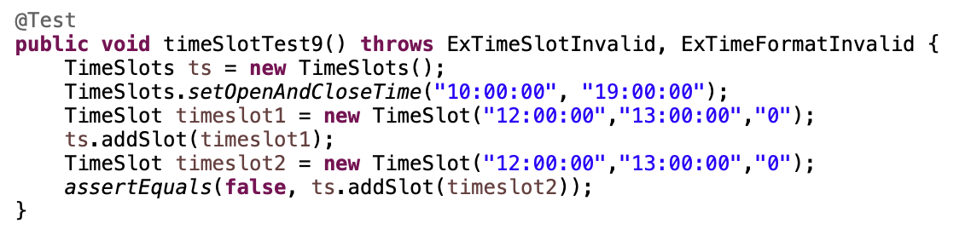

**Test 10**

Purpose: To check the function ***checkReservedStatus()***. If the timeslot is booked, then it will return -1.

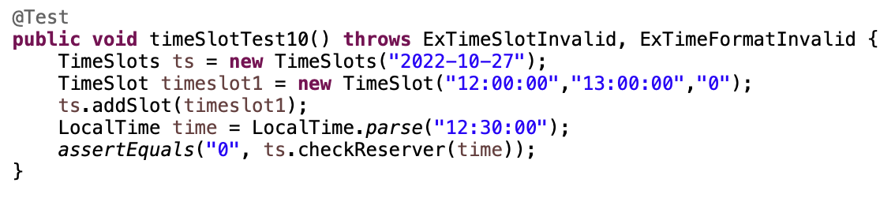

**Test 11**

Purpose: To check the function ***checkReservedStatus()***. If the timeslot start time is reached, then it will return 0.

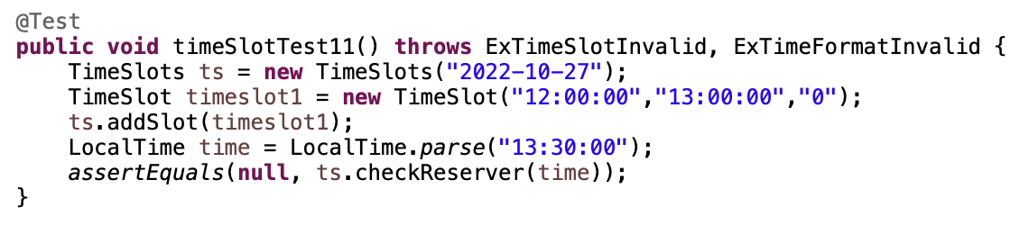

**Test 12**

Purpose: To check the function ***getAvailableSlots()***.

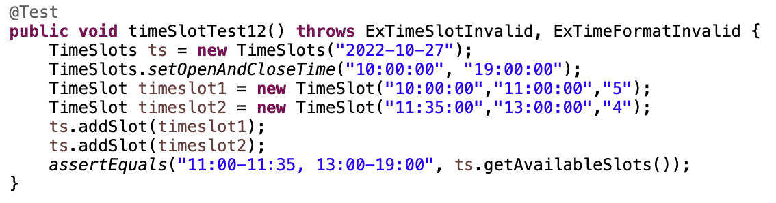

**Test 13**

Purpose: To check the function ***hasReserved()*** without reservation.

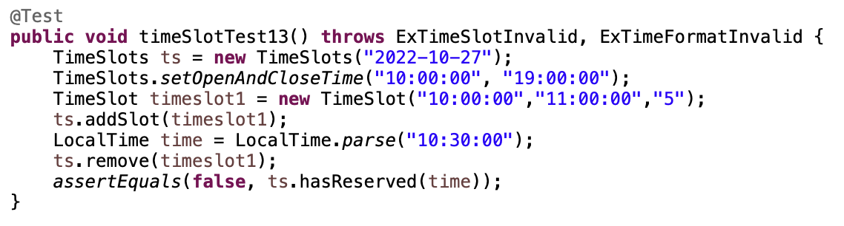

**Test 14**

Purpose: To check the function ***hasReserved()*** with reservation.

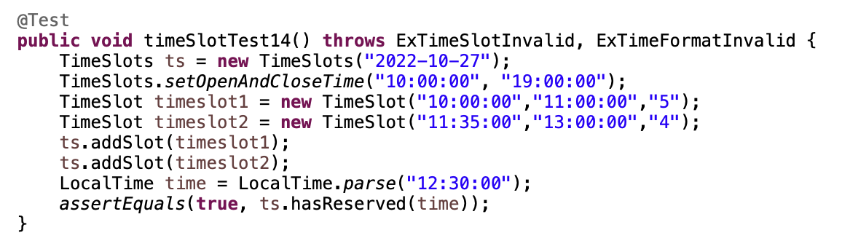

**Test 15**

Purpose: To check the function ***checkReservedStatus()*** while the reservation is expired.

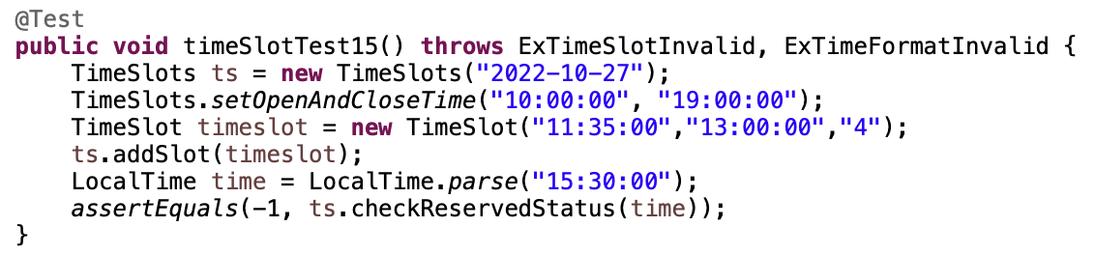

**Test 16**

Purpose: To check the function ***checkReservedStatus()*** while the reservation is on time.

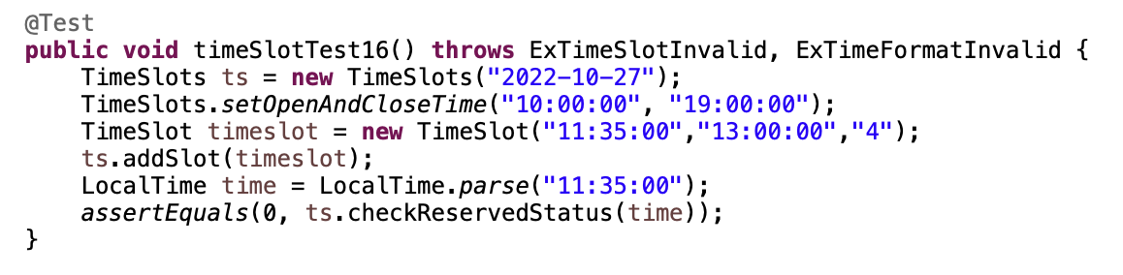

**Test 17**

Purpose: To check the function ***checkReservedStatus()*** when it’s not the reservation time.

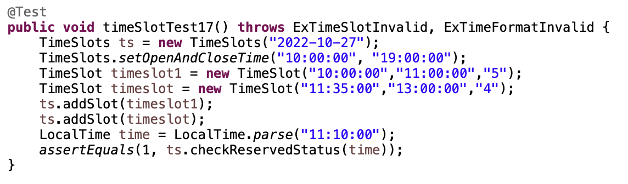

**Test 18**

Purpose: To check the function ***checkValidReserver()*** with valid reservation time.

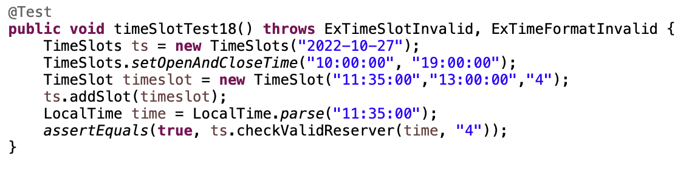

**Test 19**

Purpose: To check the function ***checkValidReserver()*** with invalid reservation time.

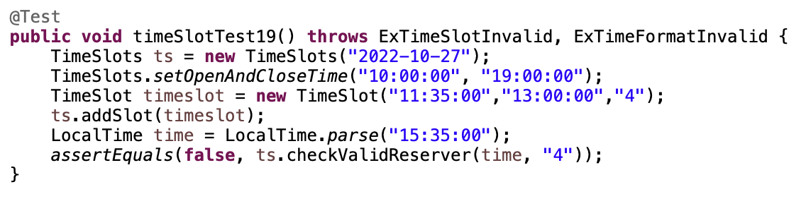

**3.2 TablesManagement.java**

Branch Coverage:

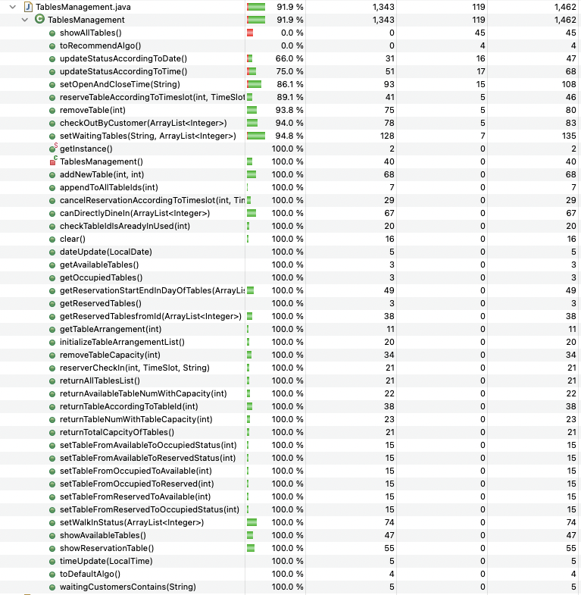

Because some functions inside Tablesmanagement are not suited for testing by directly inputting some fake value, or it is meaningless to test, for example, ***checkOutByCustomer()*** needs other classes, and some initial setup of the whole system, or ***getAvailableTables(***) only returns an ArrayList. Therefore the testing cases only cover the functions which are crucial and unique to the ***TablesManagement*** class itself.

**Test 1:** Testing the ***addNewTable()*** function

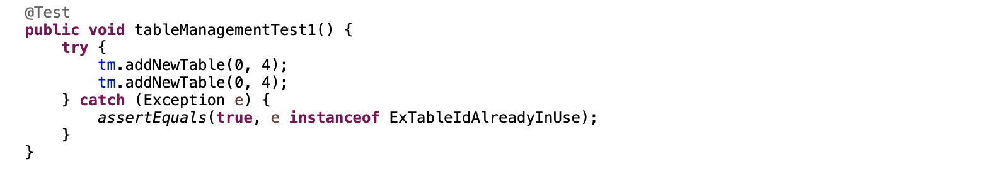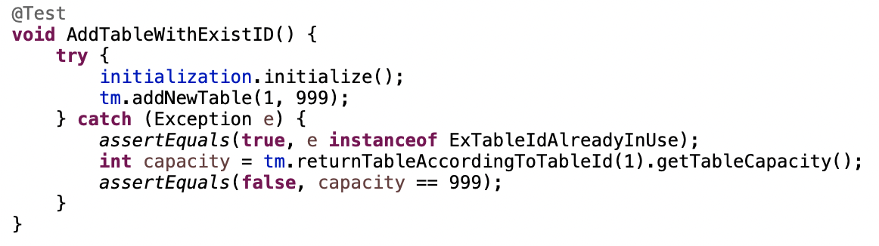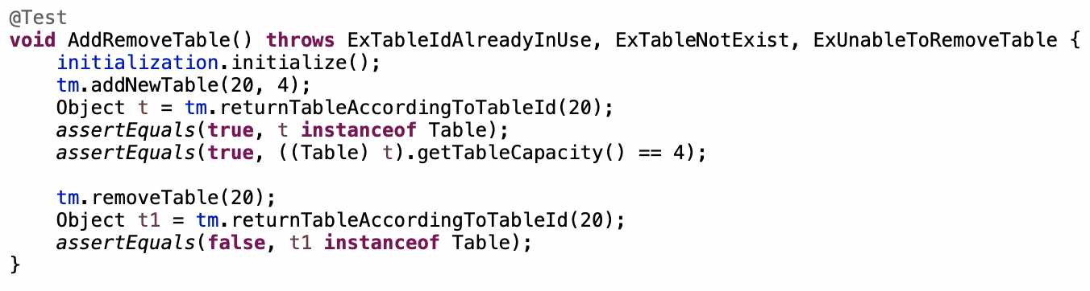

**Test 2:** Testing Remove Table

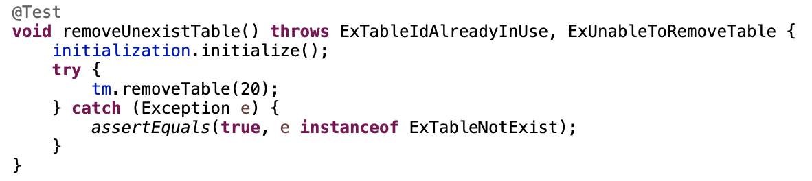

**Test 3:** Testing the ***showAvailableTables*** function

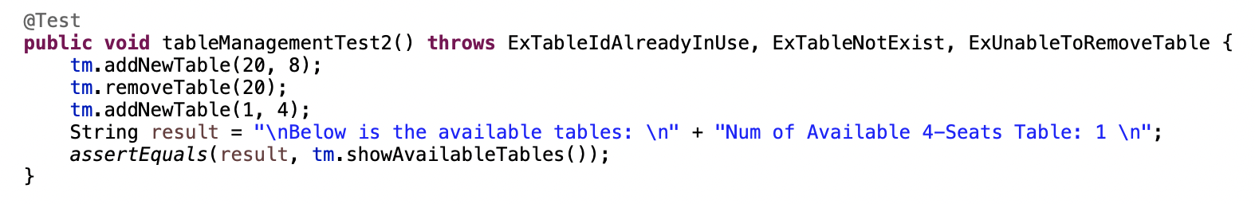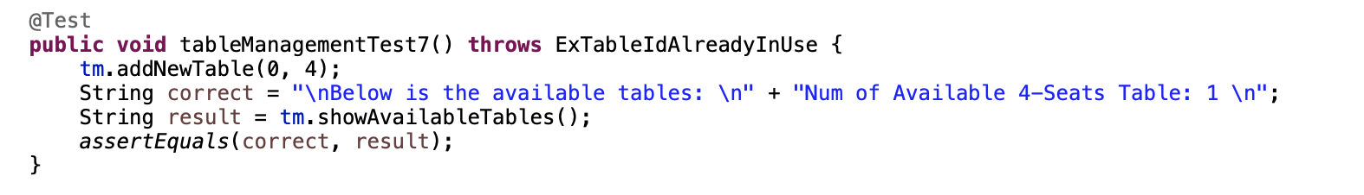

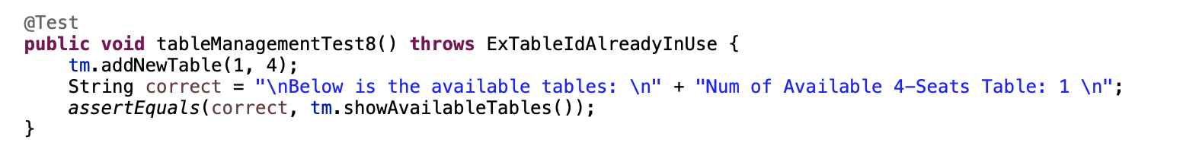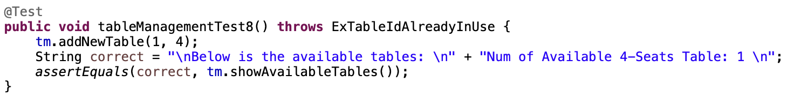

**Test 4:** Testing ***showReservationTable*** function

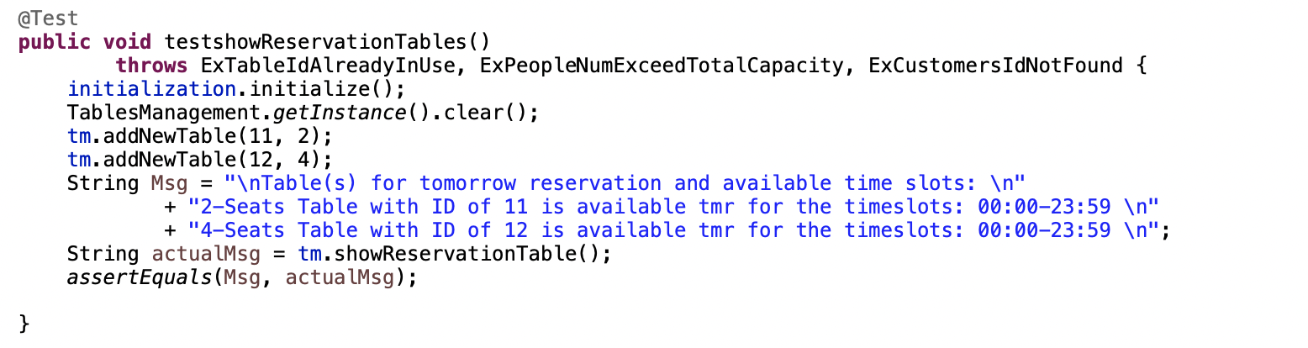

**Test 5:** Testing ***returnTotalCapacityOfTables*** function

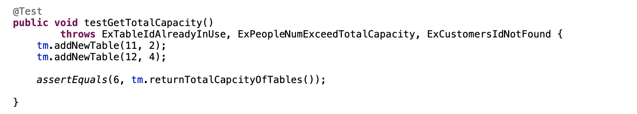

**3.3 ManualClock.java**

Branch Coverage:

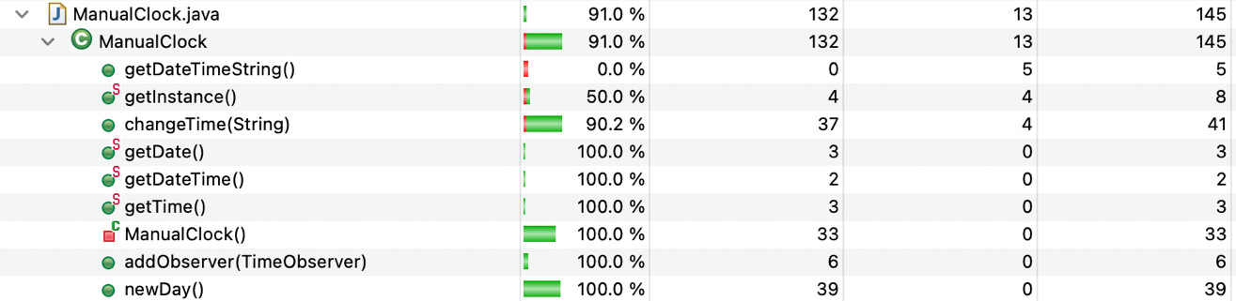

**Test 1**

Purpose: To test whether the function ***getTime()*** can successfully get the current time in reality.

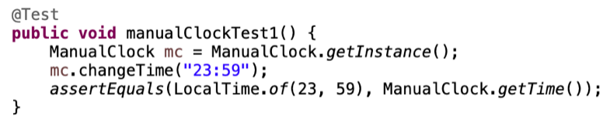

**Test 2**

Purpose: To test whether the function ***getDate()*** can set a new date in the system according to the input value.

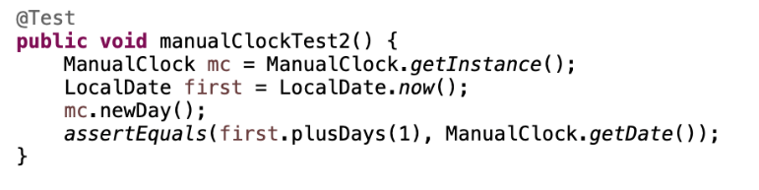

**3.4 AccountManagement.java**

* Login Account
* Delete Account
* Sorting Algorithm
* Distinguish User Module

Branch Coverage:

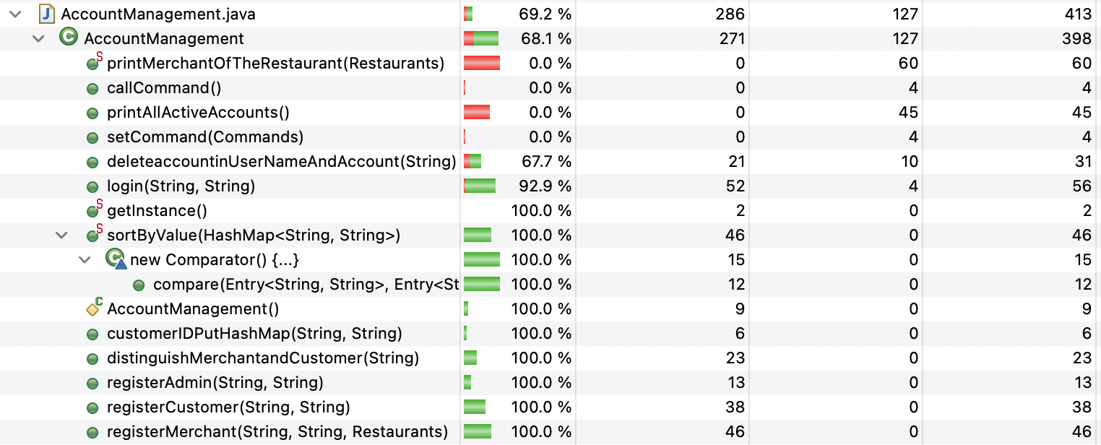

**Test 1:** Login for a non-existing account:

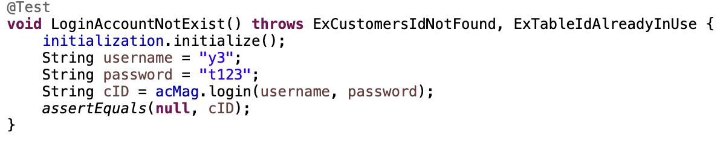

**Test 2:** Login for an existing customer account:

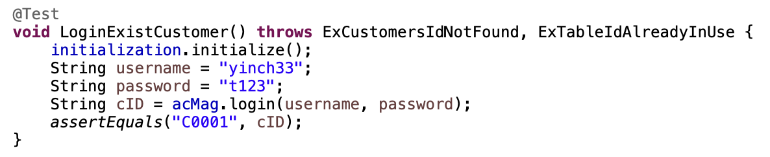

**Test 3:** Login for an existing merchant account:



**Test 4:** Login for an existing admin account:

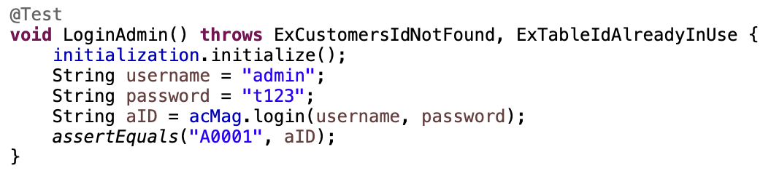

**Test 5:** Login with the wrong password:

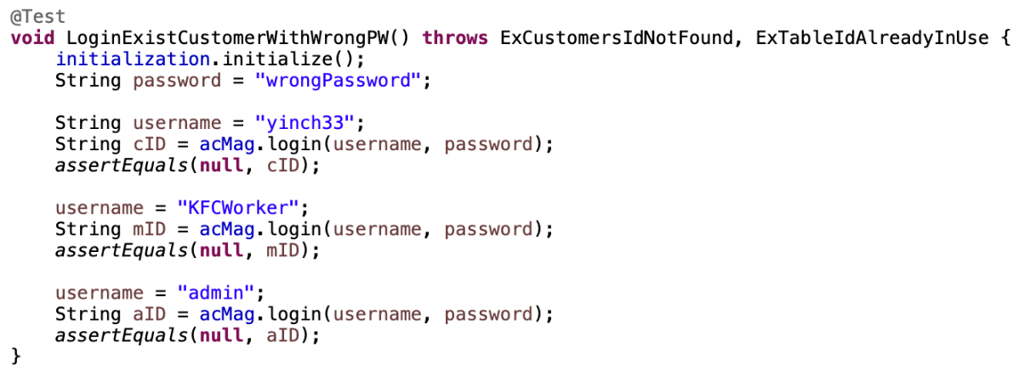

**Test 6:** Delete user:

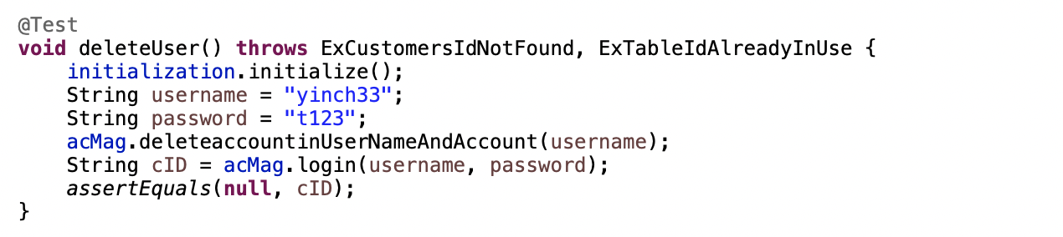

**Test 7:**  Sorting accounts

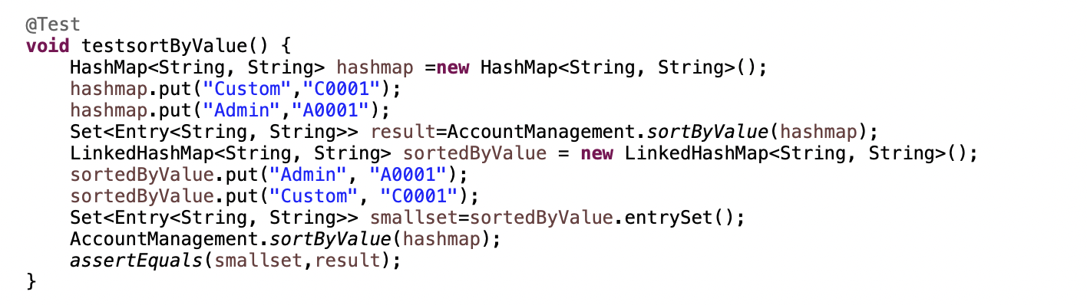

**Test 8:** Testing distinguish accounts function

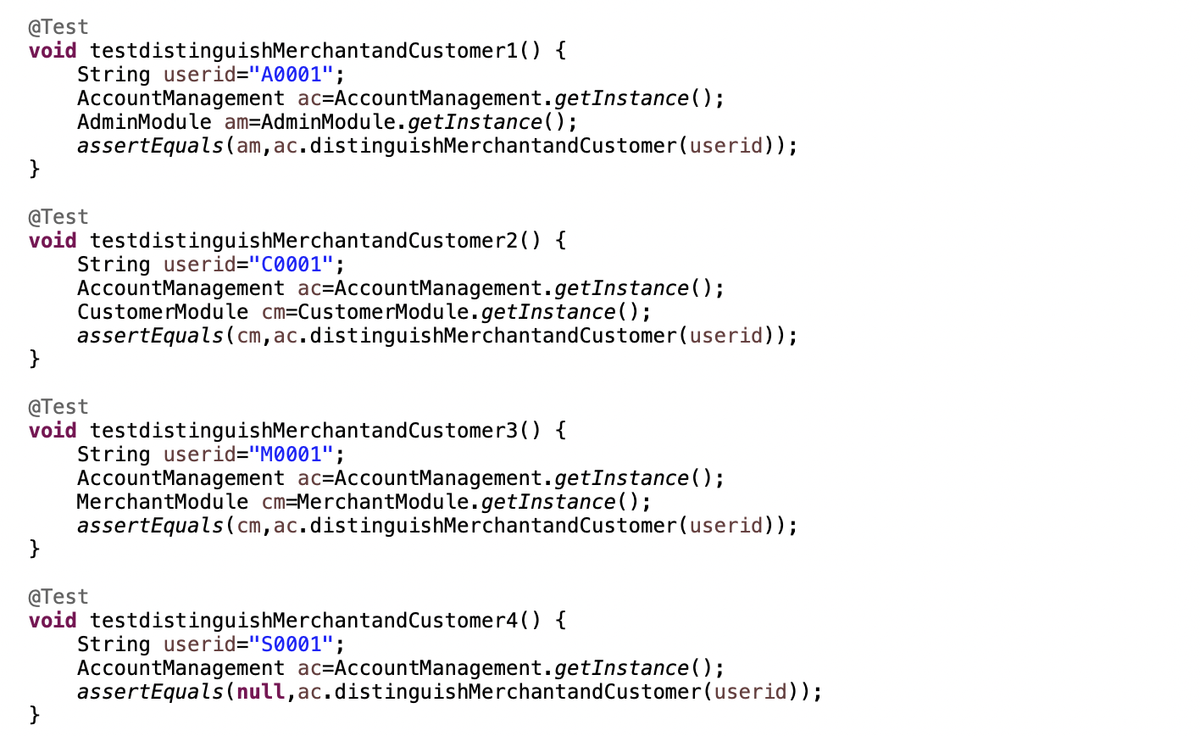

**3.5 Dish.java**

Branch Coverage:

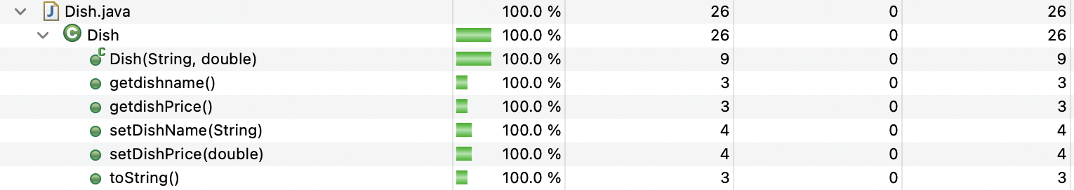

**Test 1: Edit dish name:**

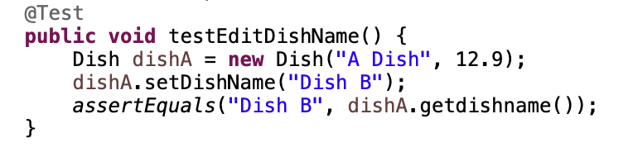

**Test 2: Edit dish price:**

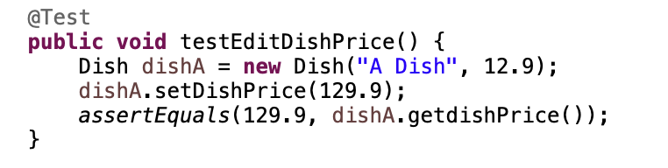

**3.6 Customer.java**

**Test 1: Get user name:**

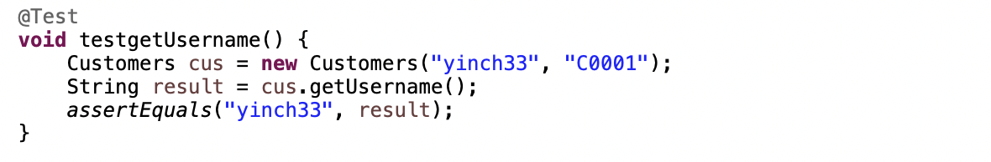

**Test 2: Get user ID:**

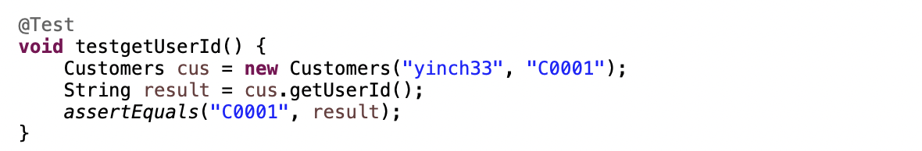

**4. Integration Test**

**4.1 White-Box Testing**

The structure of the white-box integration testing:

* Login Module
* Register
* Login
* Delete Account
* Admin Module
* Set Open Close Time
* Add / Remove Restaurant
* Add / Remove Table
* Check Reservation
* Customer Module
* Dine In
* Reserve
* Cancel Reserve
* Check Out
* Update State
* Merchant Module
* Modify Dish
* Table Management Module
* Table Arrangement Algorithm
* Default Table Arrangement Algorithm
* Recommended Arrangement

**4.1.1 Login Module**

* Register Part

Branch Coverage for ***GenerateCustomerId.java***:

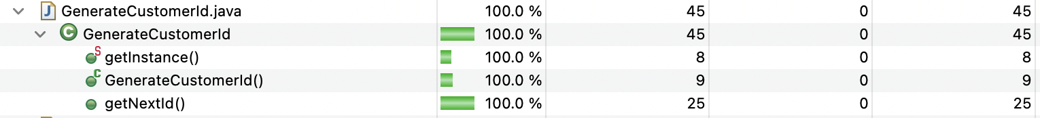

Branch Coverage for ***GenerateMerchantId.java***:

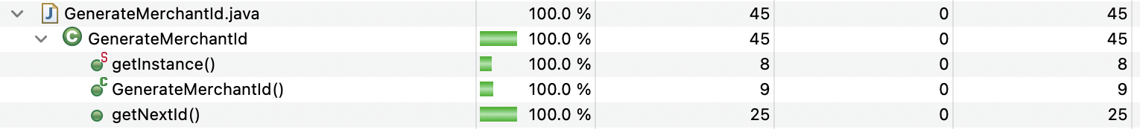

**Test 1:** Register for new customer:

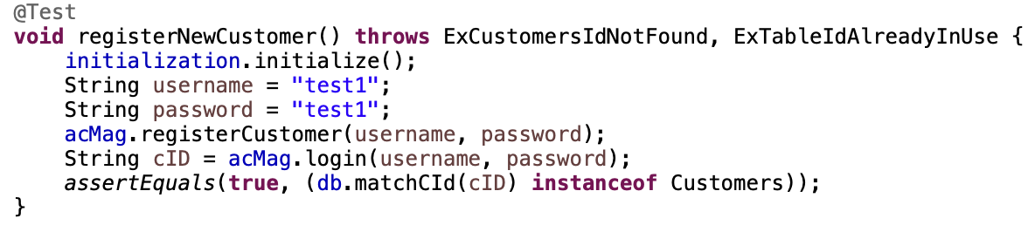

**Test 2:** Register for an existing customer:

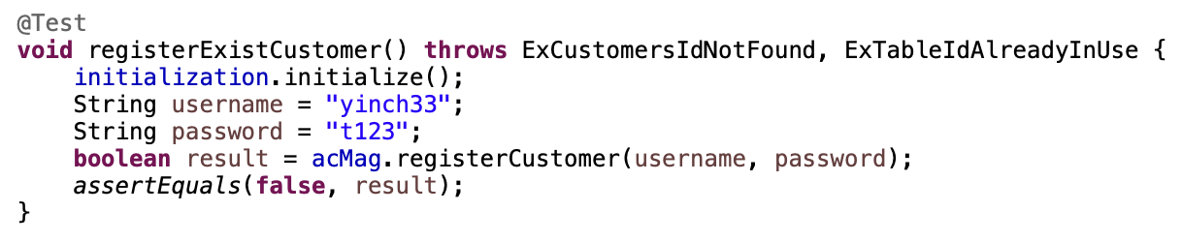

**Test 3:** Register for new merchant:

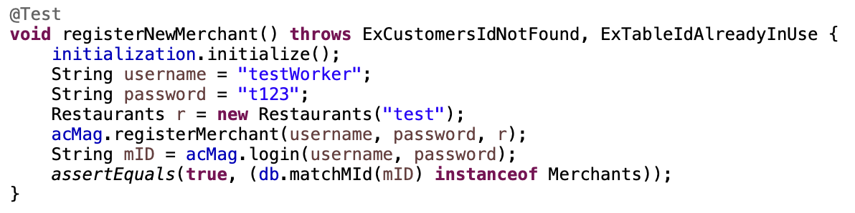

**Test 4:** Register for existing merchant:

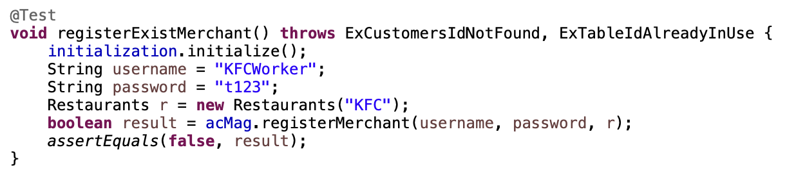

**4.1.2 Admin Module**

#### 4.1.2.1 Set Open and Close Time

Admin set open and close time without overlap:

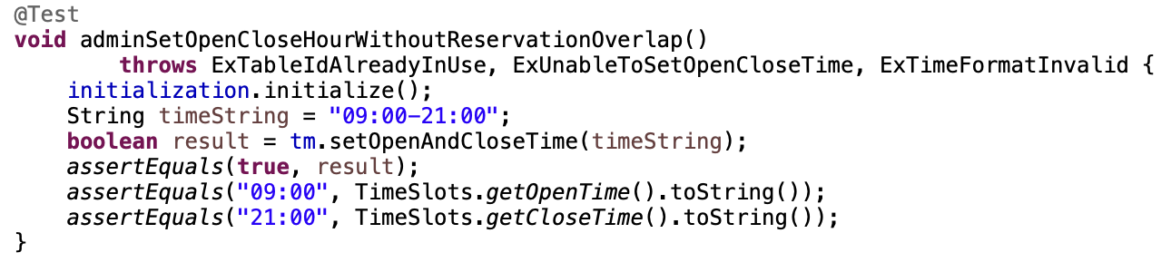

Admin set open and close time with reservation overlap:

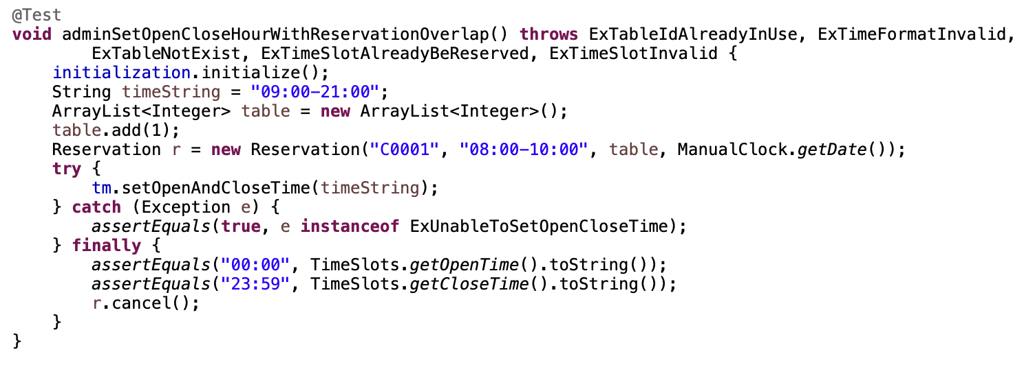

#### 4.1.2.2 Add / Remove Restaurant

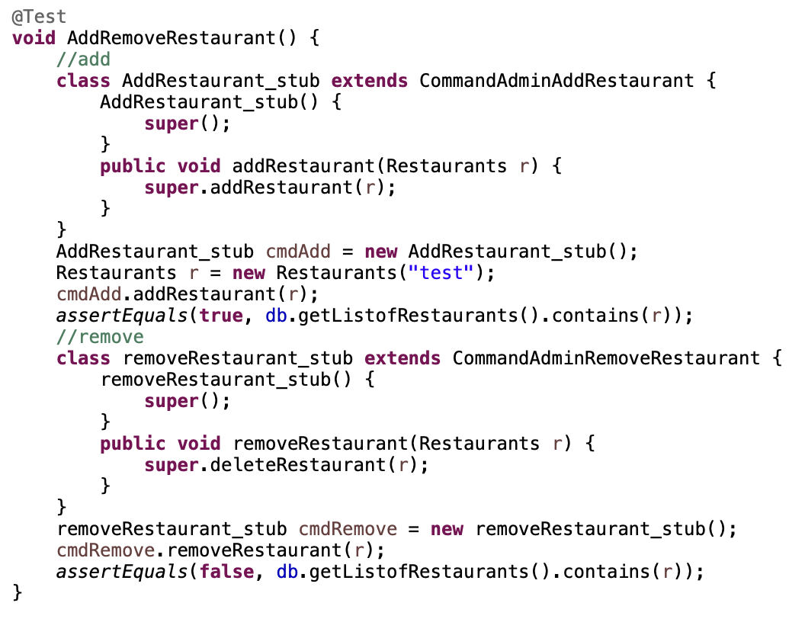

#### 4.1.2.3 Add / Remove Table

**Test 1:** Add existing table:

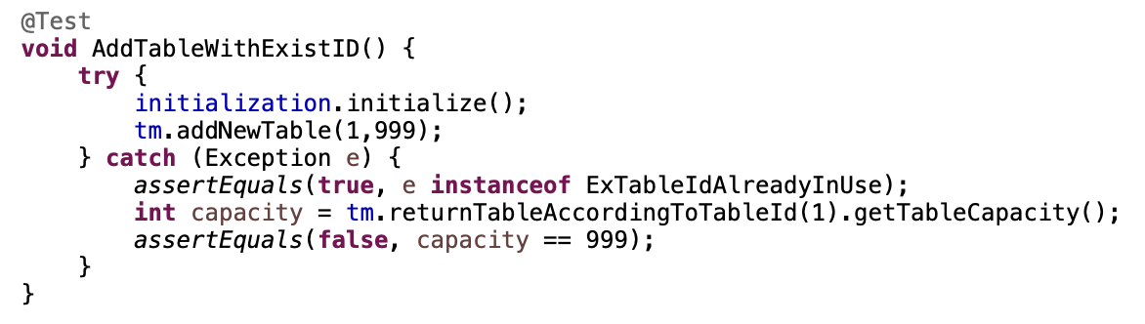

**Test 2:** Add or remove table with valid input ID:

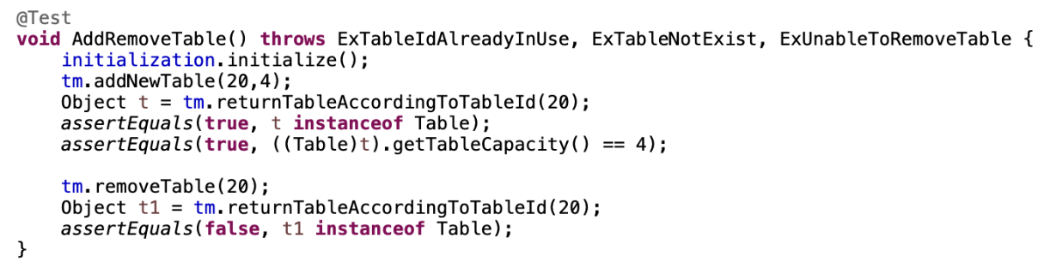

**Test 3:** Remove table which is non-existing:

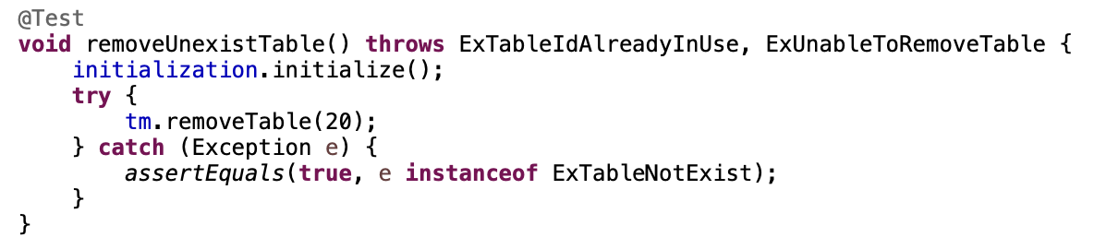

#### 4.1.2.4 Check Reservation

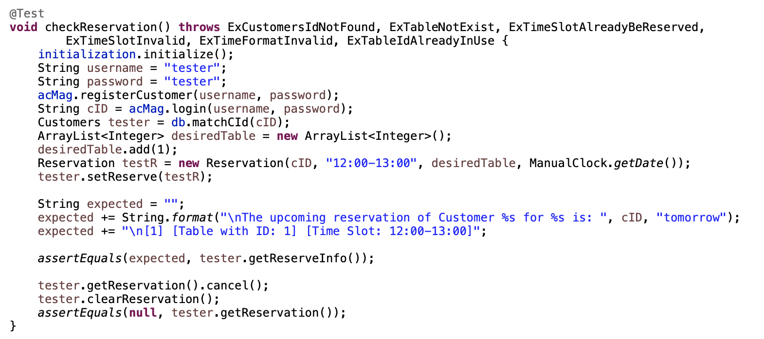

**4.1.3 Customer Module**

#### 4.1.3.1 Dine in

**Test 1:** Test Successfully Dine in operation

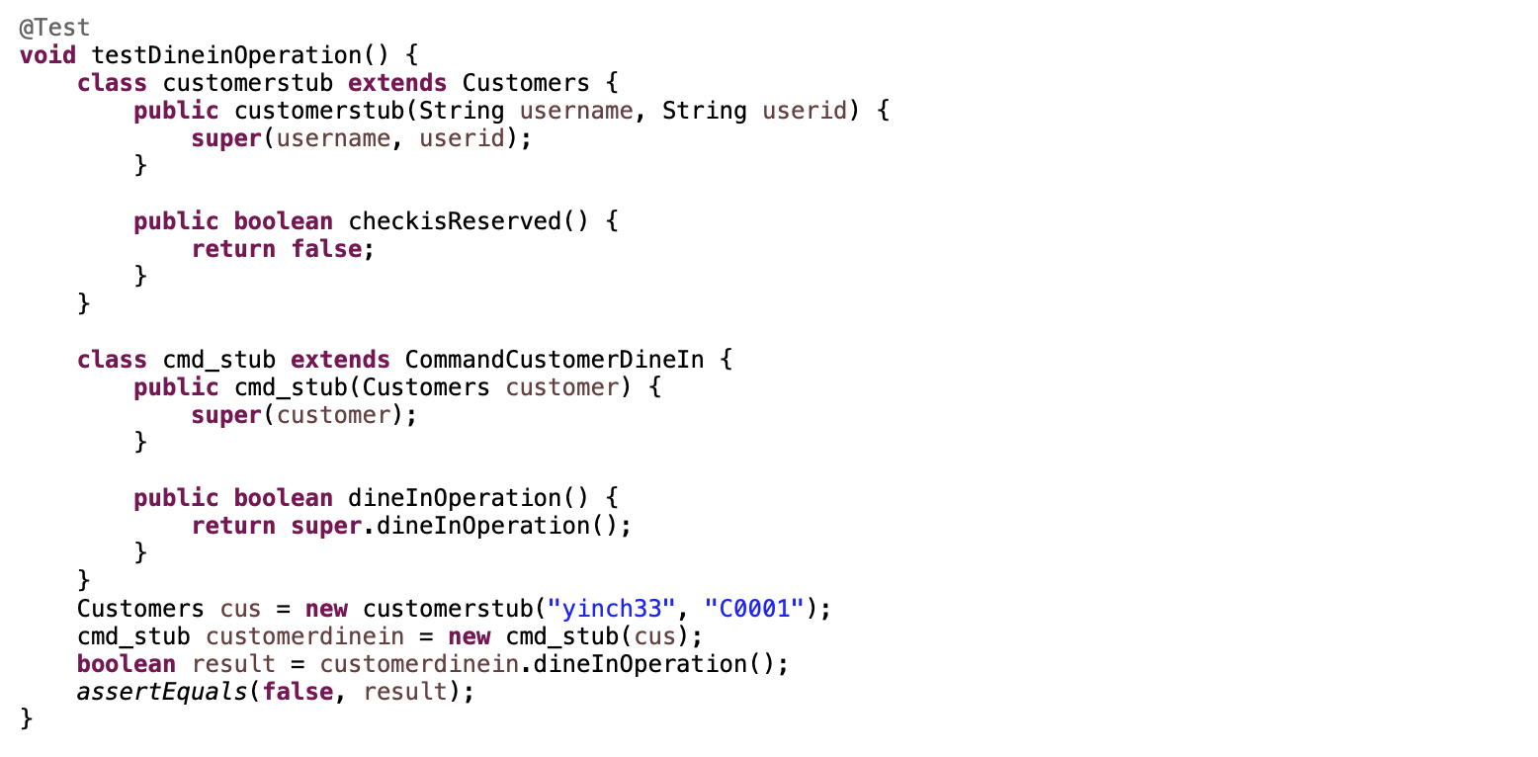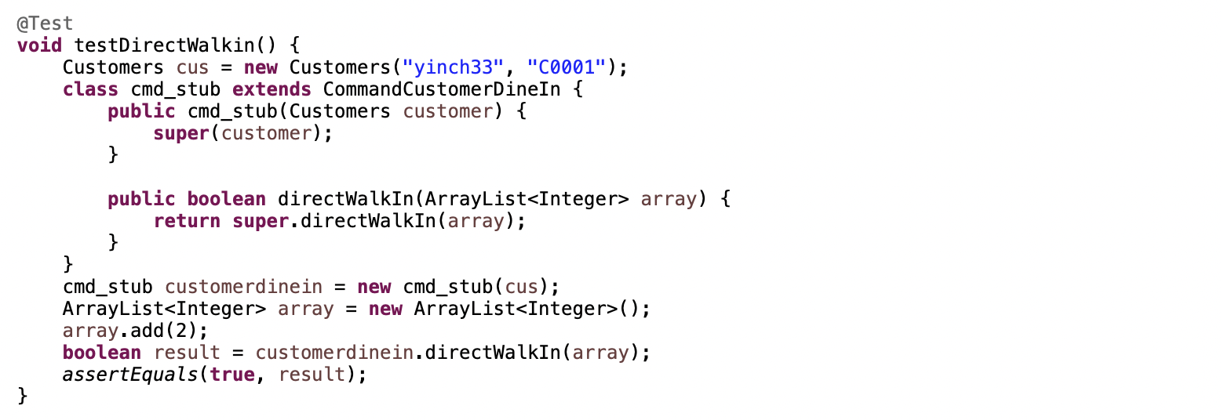

**Test 2:** Testing check in operation

Check in when walk-in: Add Occupied Table Id to customer

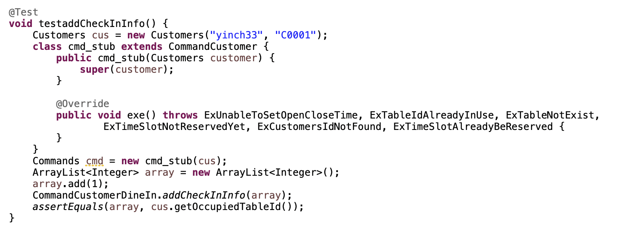

#### 4.1.3.2 Reserve

Branch Coverage:

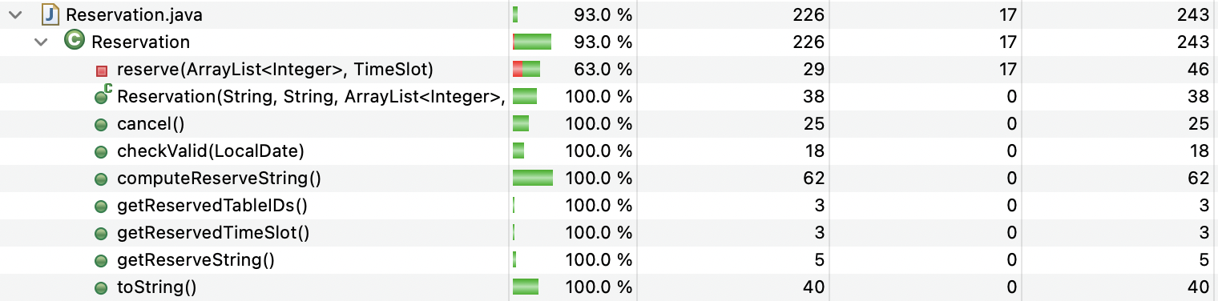

**Test 1:** Testing ***toString()*** function

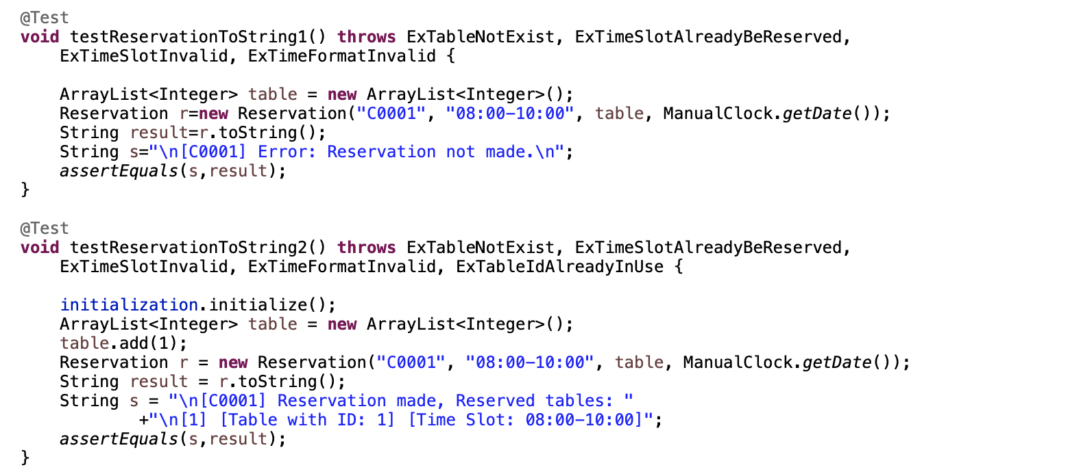

**Test 2:** Testing to print out the reservation reminder of the customer

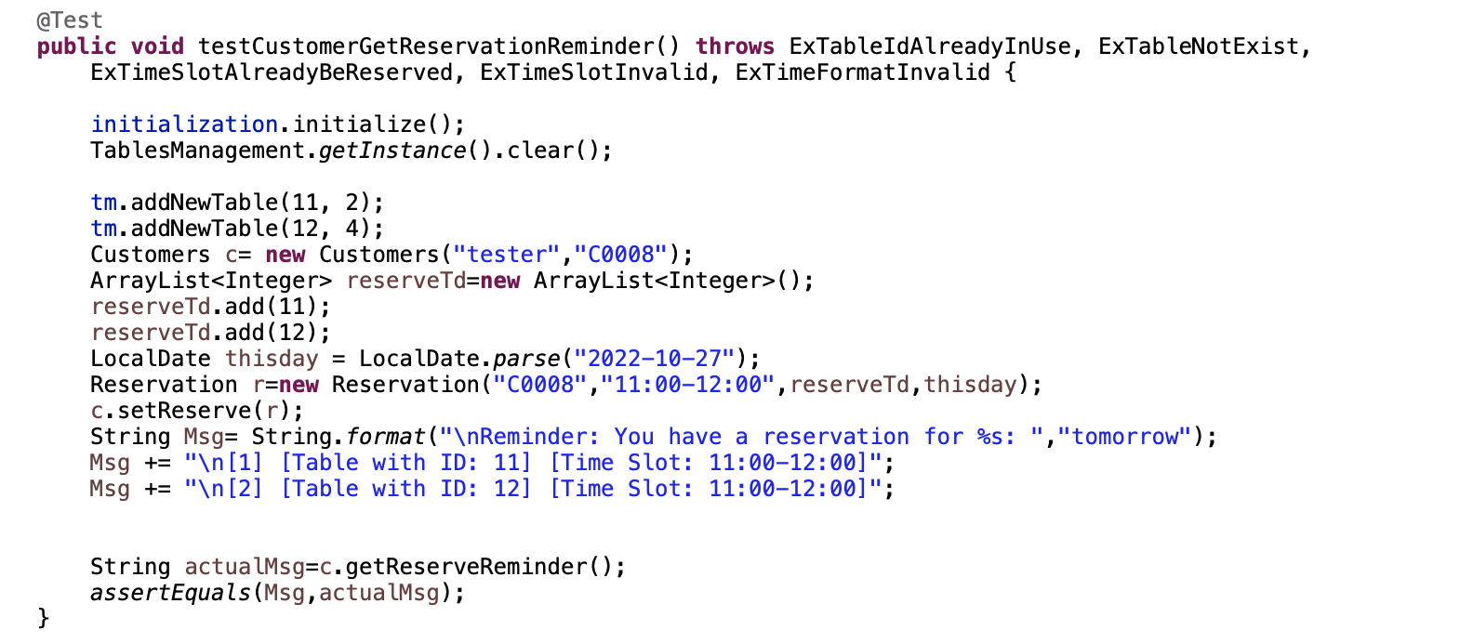

**Test 3**: Testing ***checkValid*** function

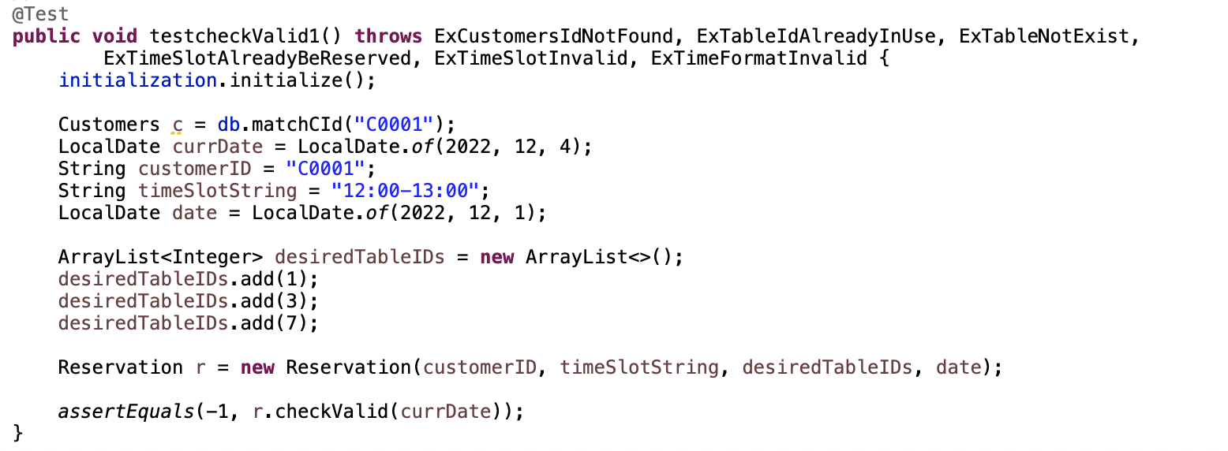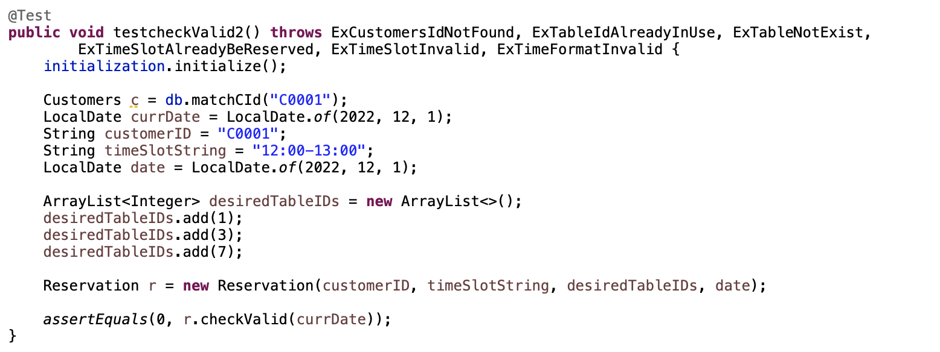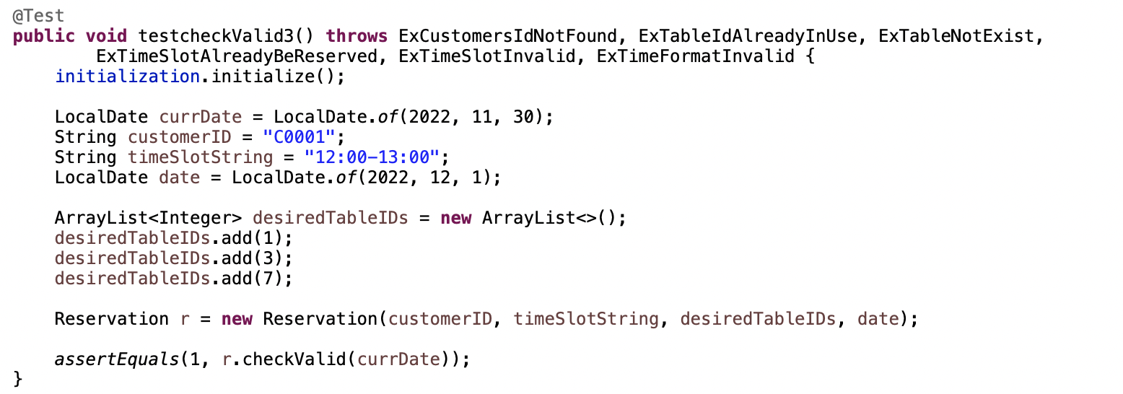

**Test 4:** Testing to obtain the reservation information of the customer

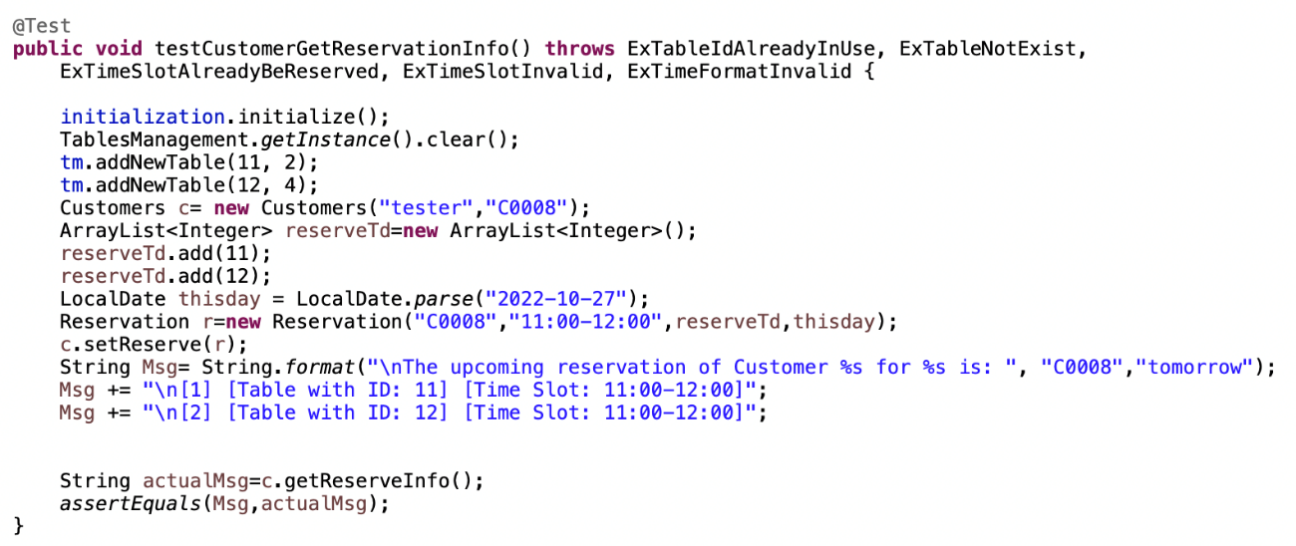

**Test 5:** Testing successfully make a reservation

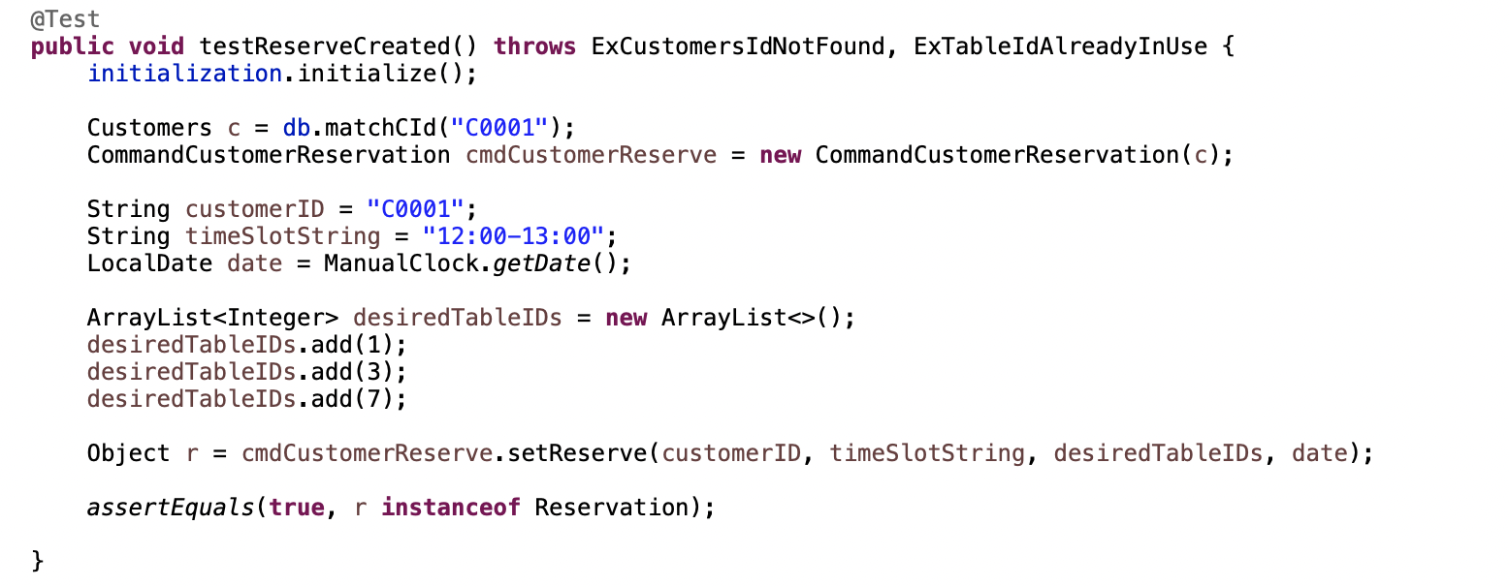

**Test 6:** Test ***checkIsReserved*** function

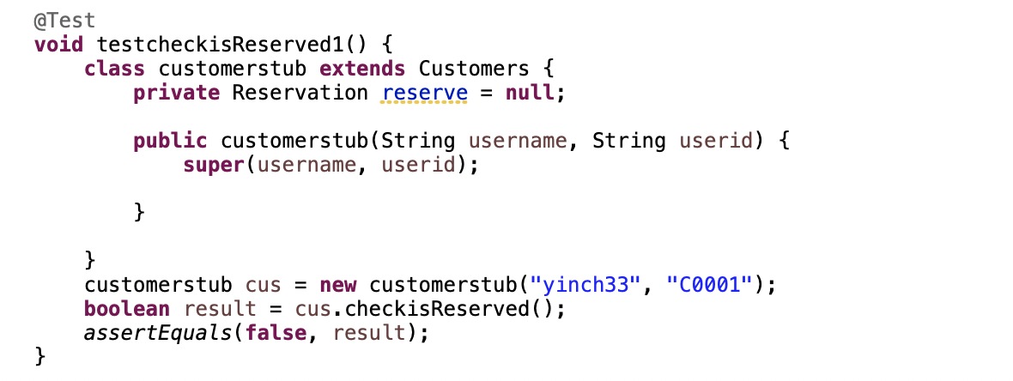

**Test 7:** Testing make reservation unsuccessful

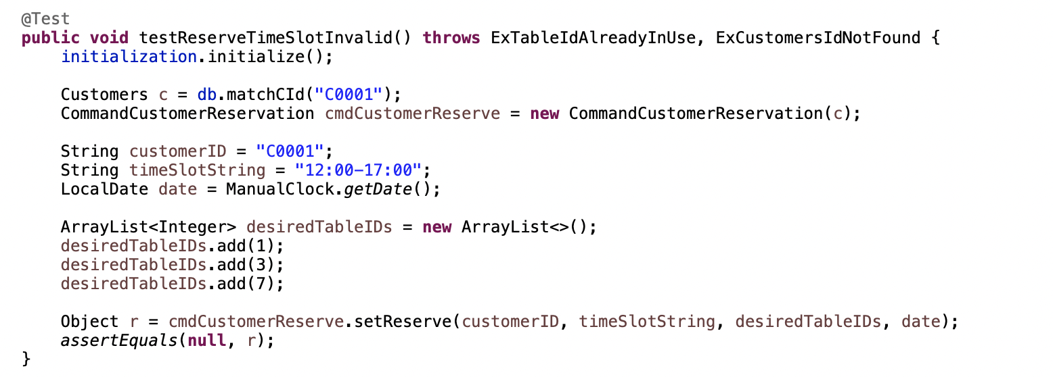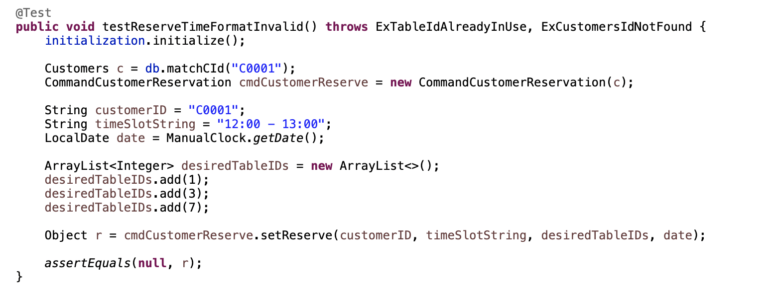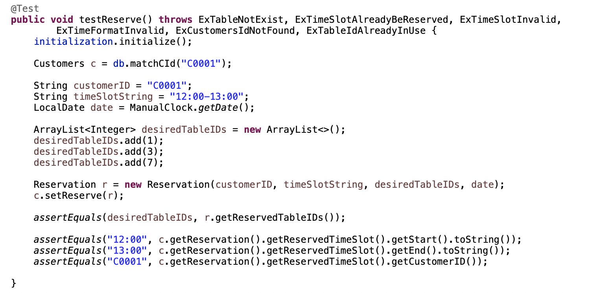

#### 4.1.3.3 Cancel Reserve

**Test 1:** Cancel existing reservation:

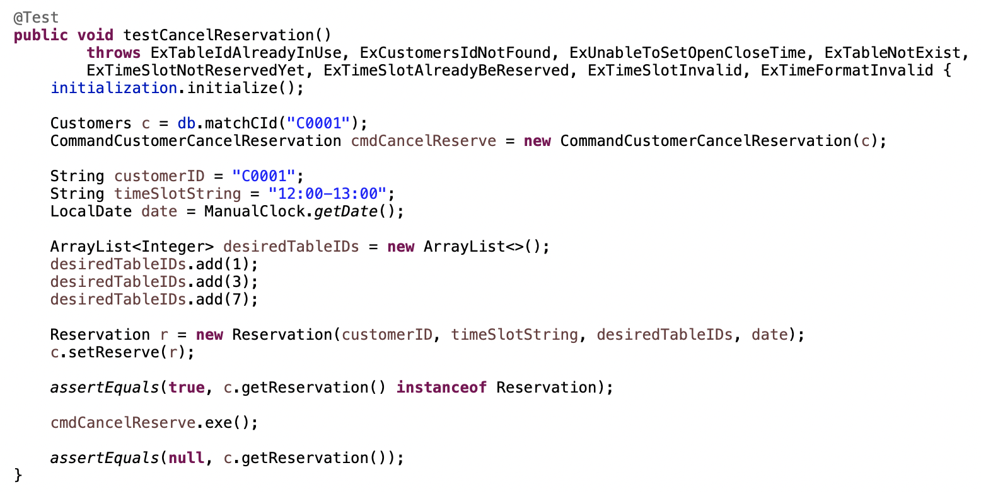

**Test 2:** Cancel non-existing reservation:

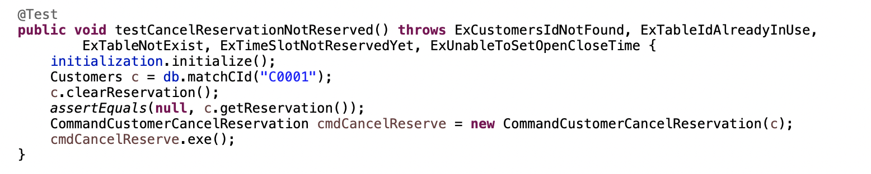

#### 4.1.3.4 Ordering

**Test 1:** Update the pending orders when not confirming order.

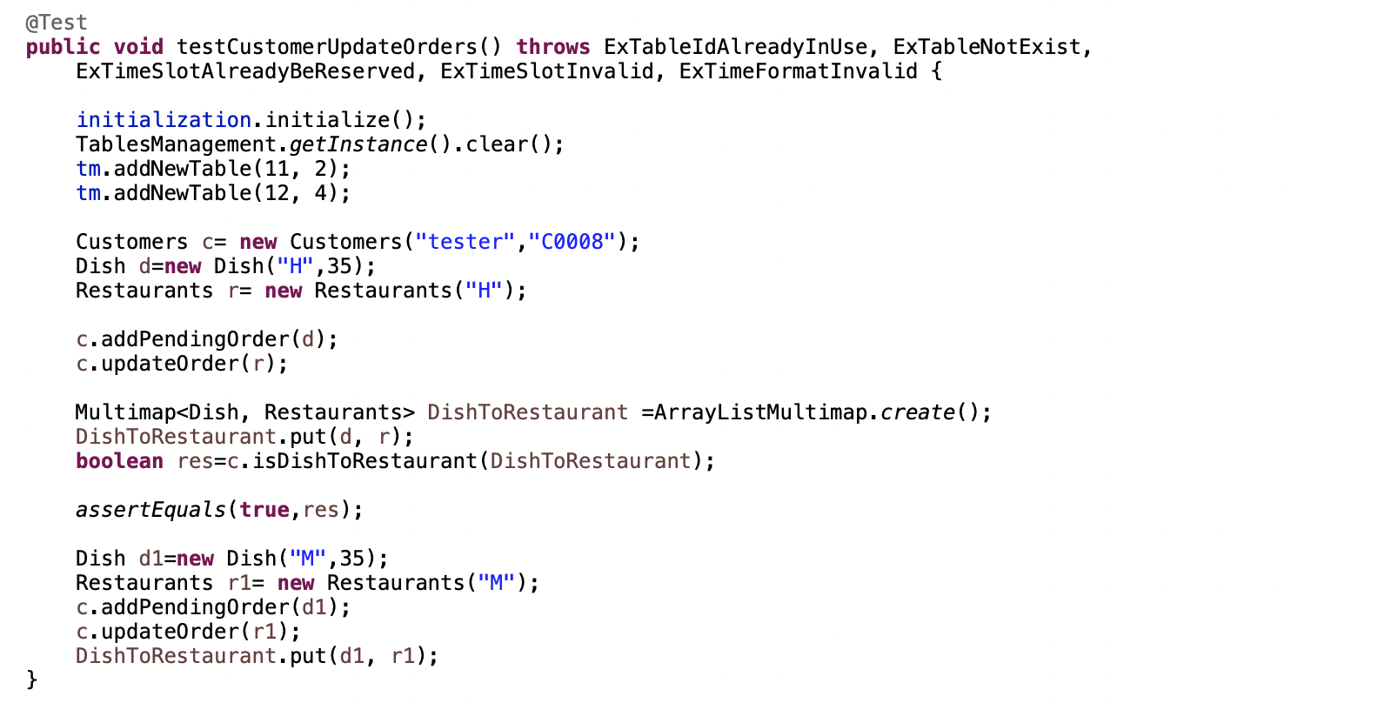

#### 4.1.3.5 Check Out

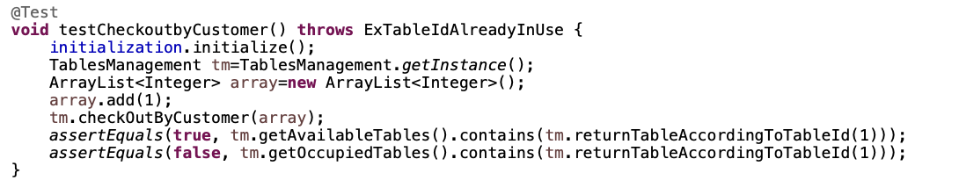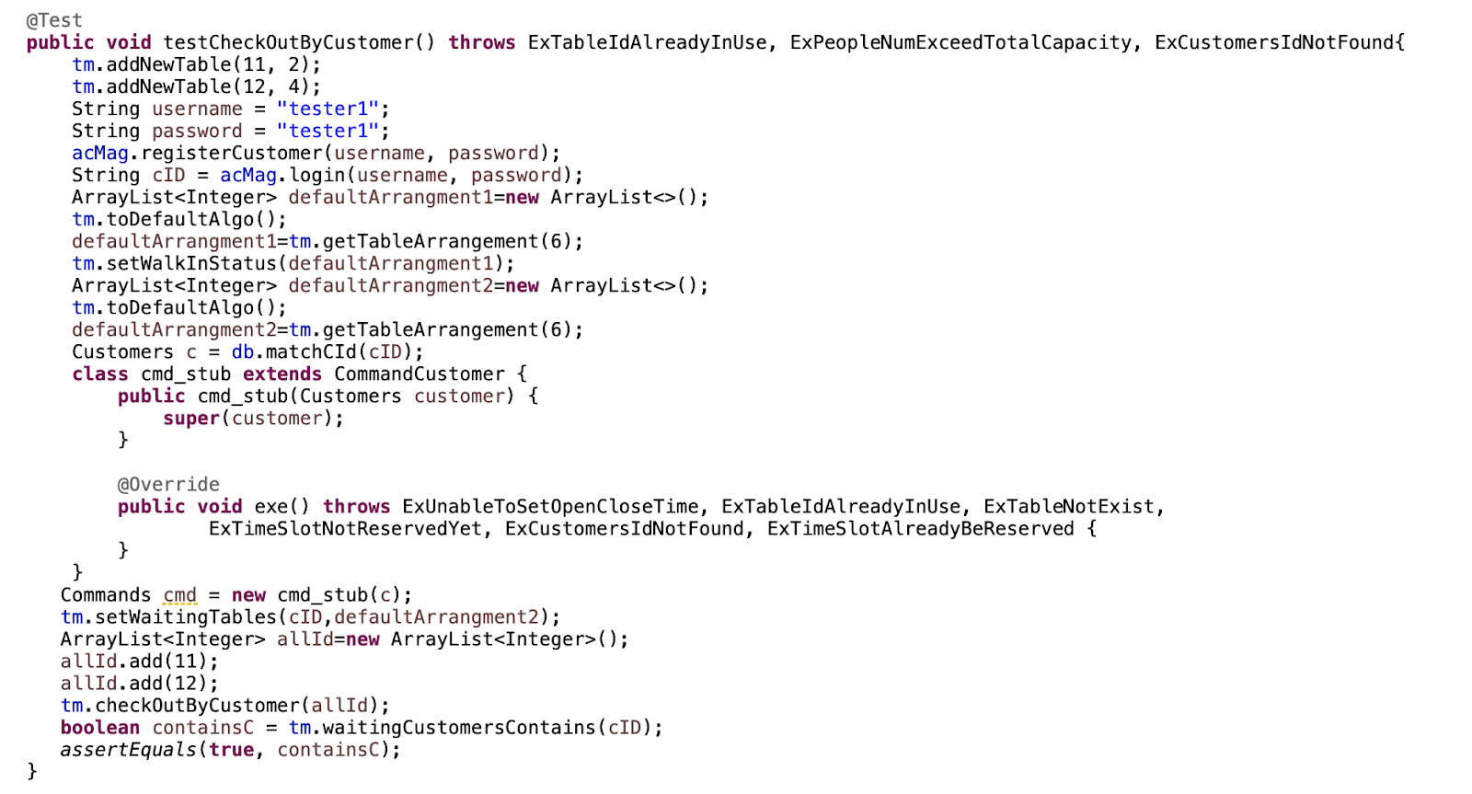

#### 4.1.3.6 Update State

**Test 1:** Test to update the state of the customer based on bill amount

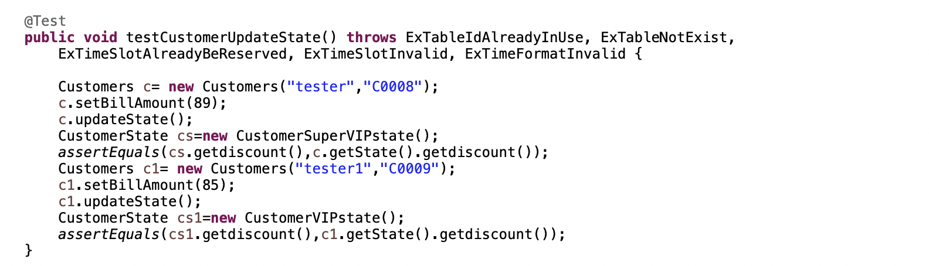

**4.1.4 Merchant Module**

#### 4.1.4.1 Modify Dish

**Test 1:** Find dish:

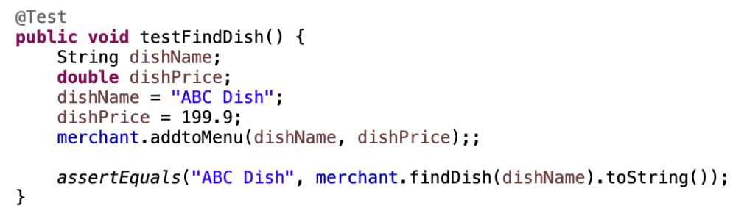

**Test 2:** Add dish:

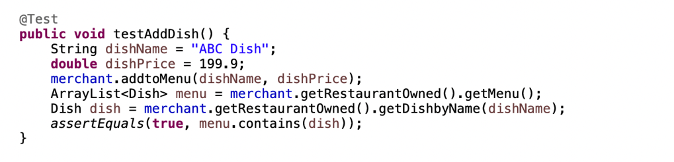

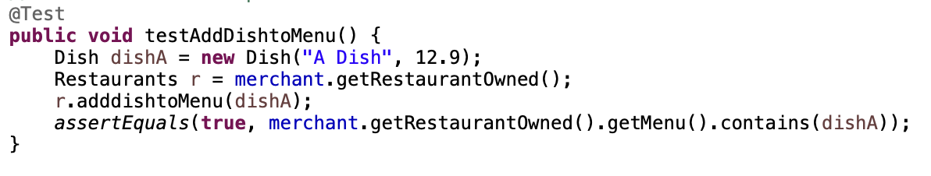

**Test 3:** Remove existing dish:

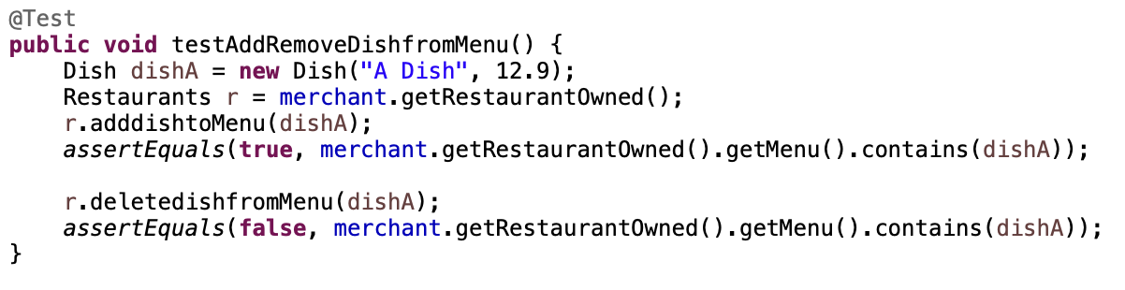

**Test 4:** Remove non-existing dish:

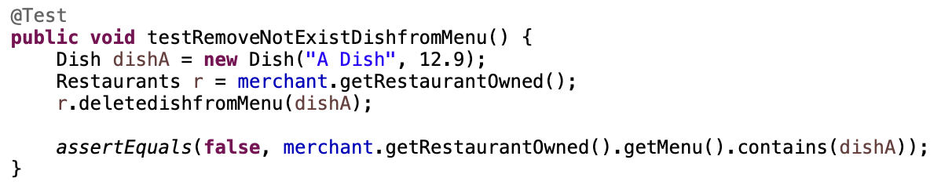

**Test 5:** Get non-existing dish:

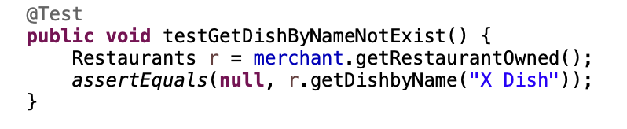

**Test 6:** Get updated menu:

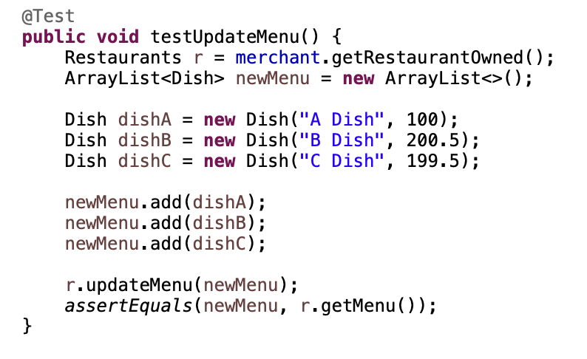

**Test 7:** Get total price:

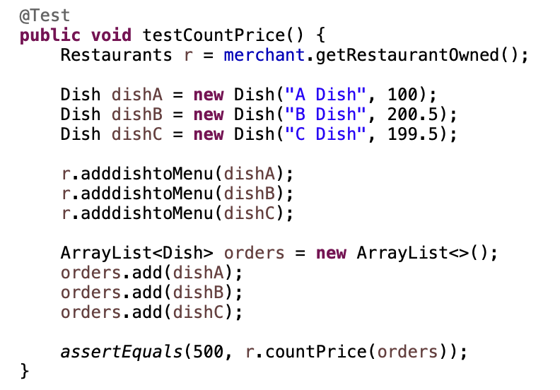

**4.1.5 Table Management**

**Test 1:** Table Status Handling

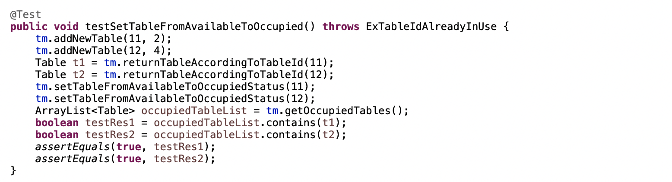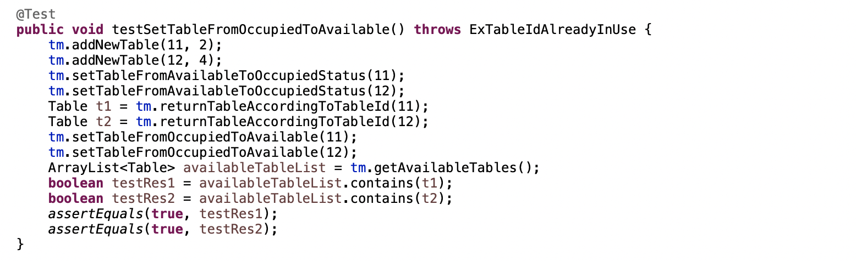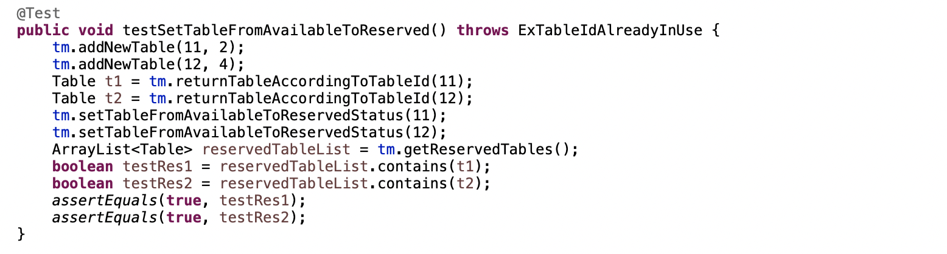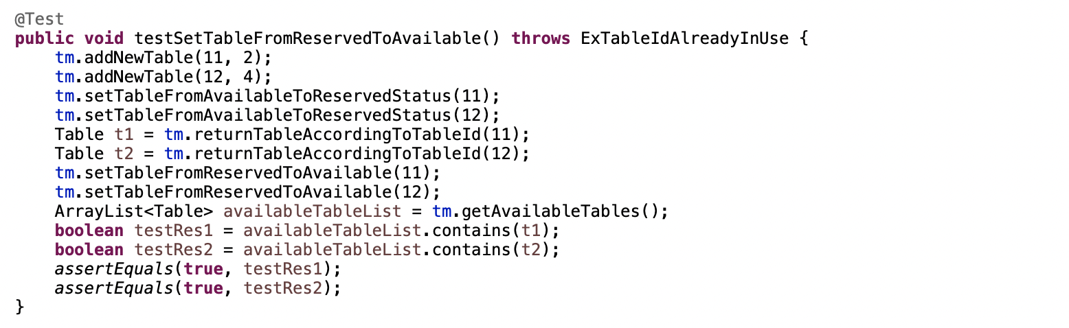

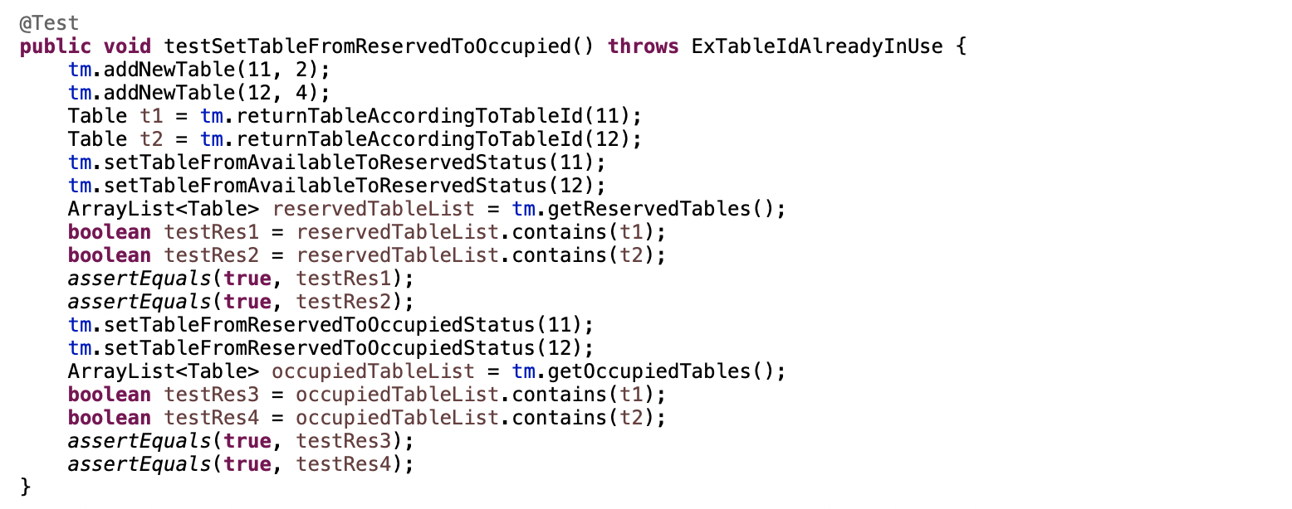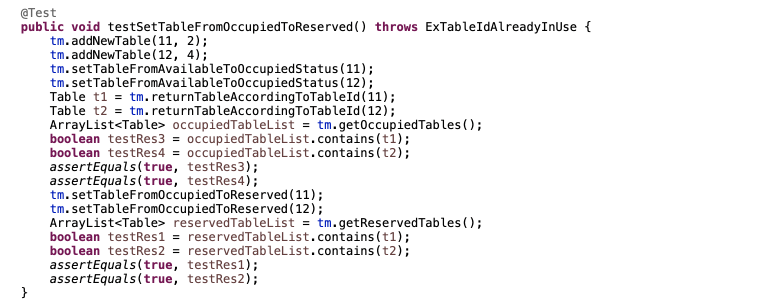

**Test 2:** Reserve Table according to Timeslot

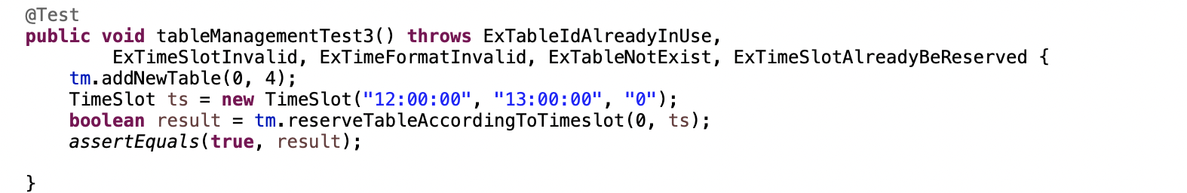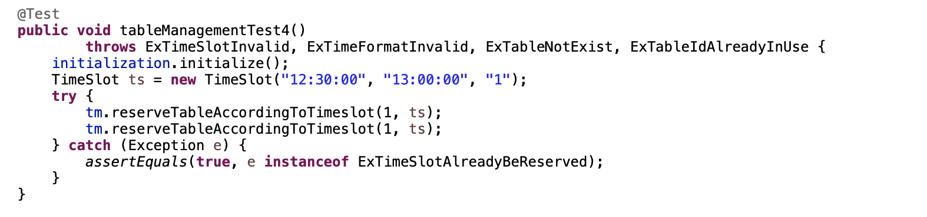

**Test 3:** Cancel Reservation according to timeslot

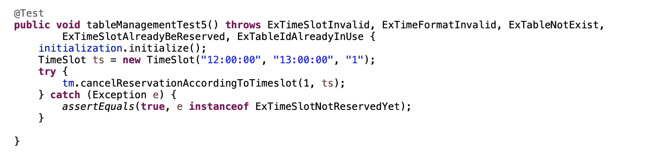

**Test 4:** Find number of available table corresponding to the capacity

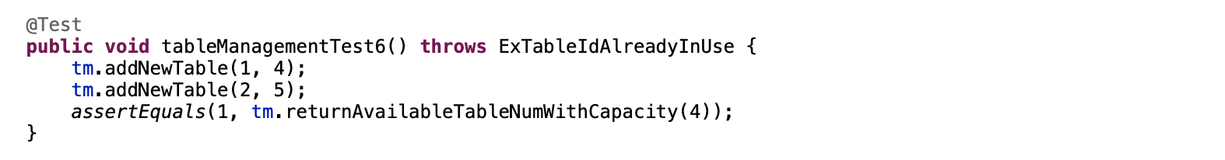

**Test 5:** Operation for reserved customer to dine in

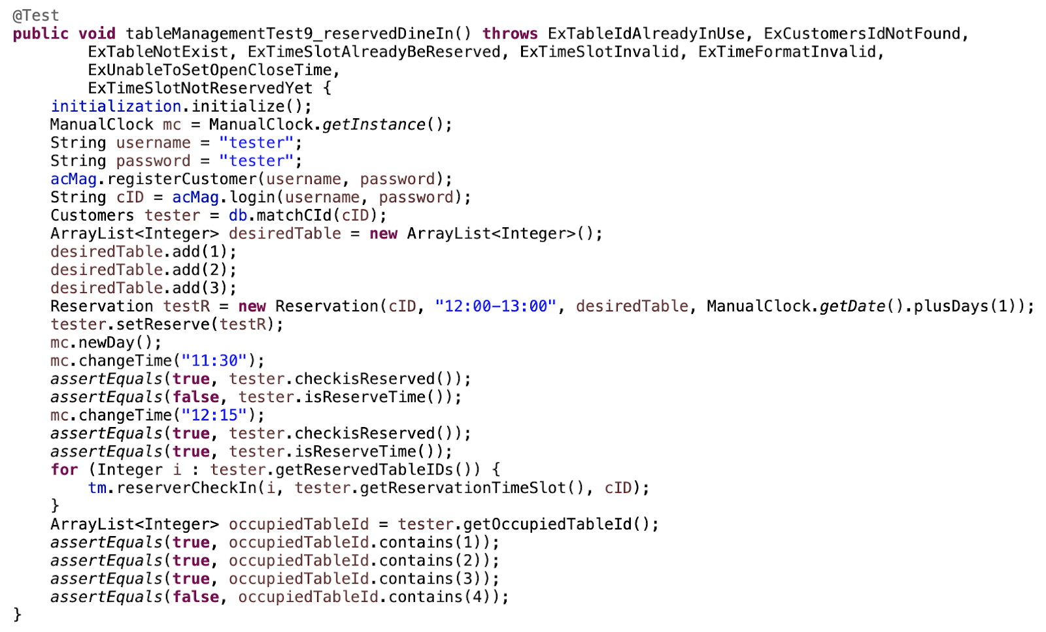

**Test 6:** Test table operation when customer direct walk in

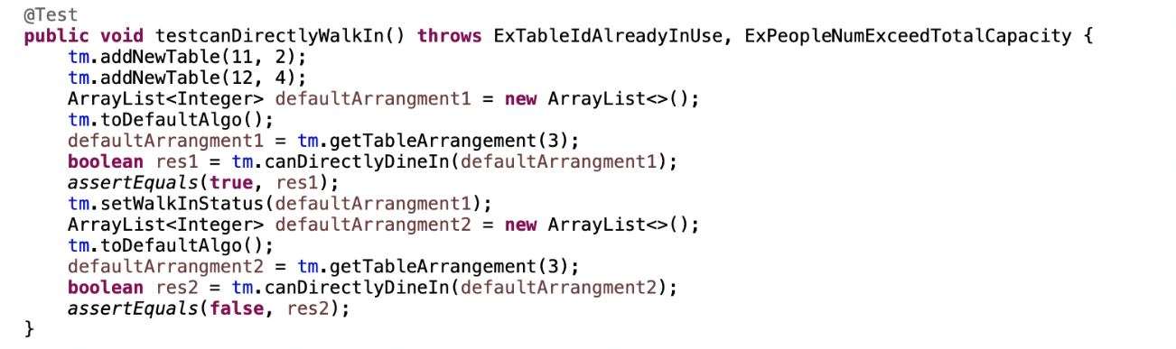

**Test 7:** Set waiting table

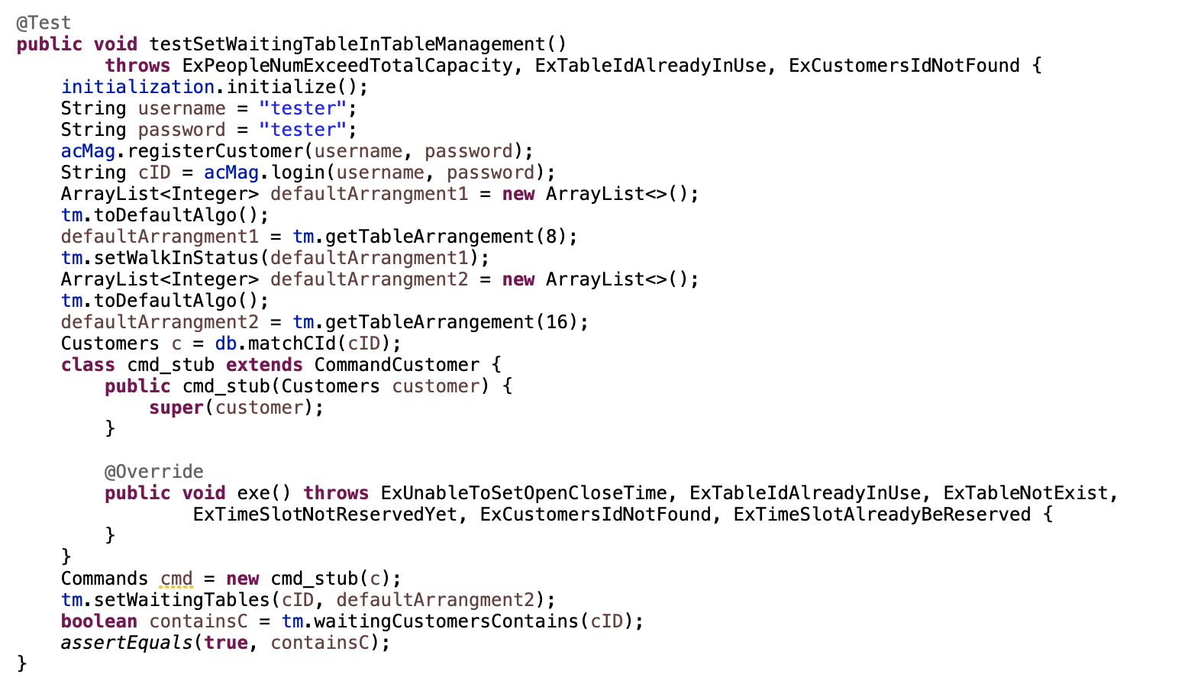

**4.1.6 Table Arrangement Algorithms**

There are two algorithms of the table arrangement:

* Default Arrangement
* Recommended Arrangement

#### 4.1.5.1 Default Table Arrangement Algorithm

Branch Coverage:

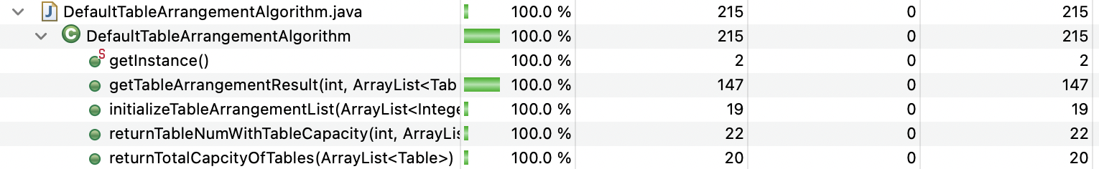

**Test 1:** Initializing Table Arrangement List

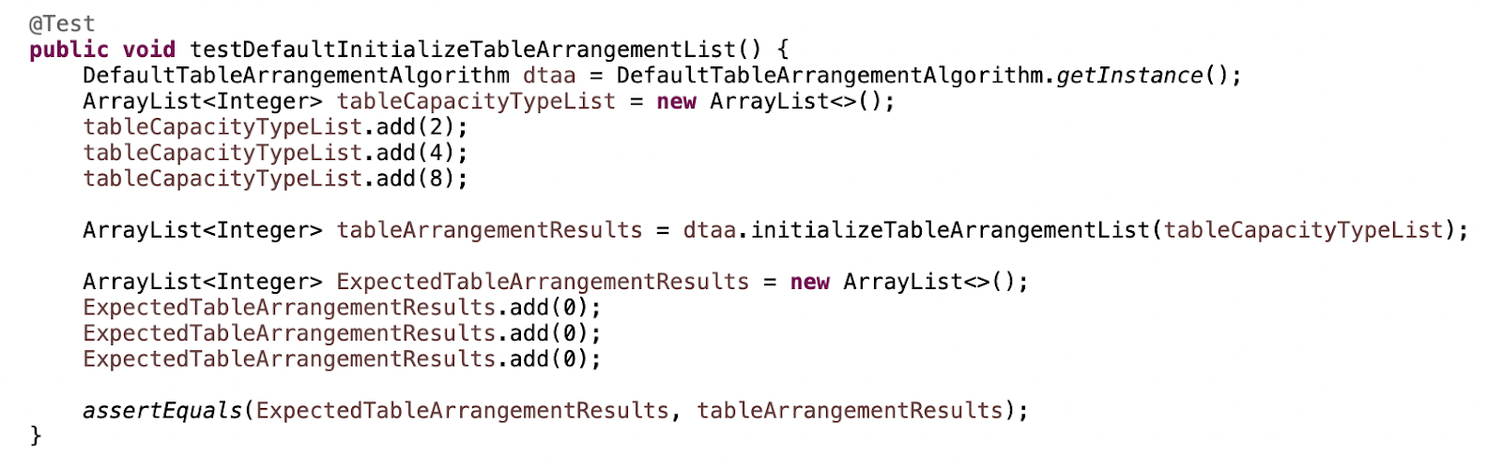

**Test 2:** Returning Number of Tables of the Table Capacity

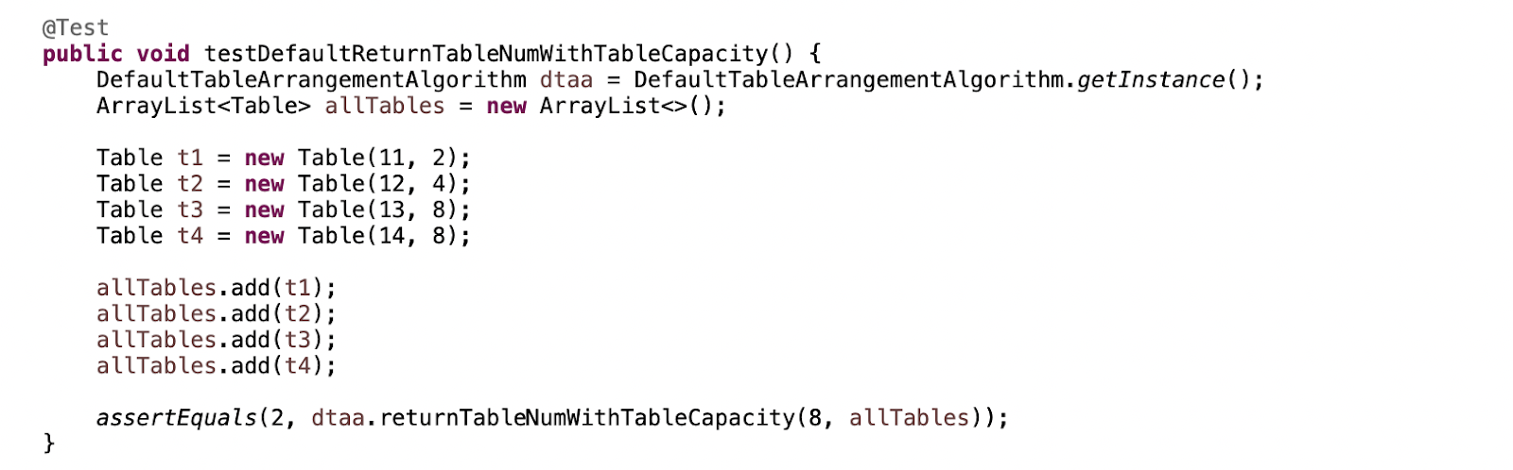

**Test 3:** Calculate the Overall capacity of all the tables

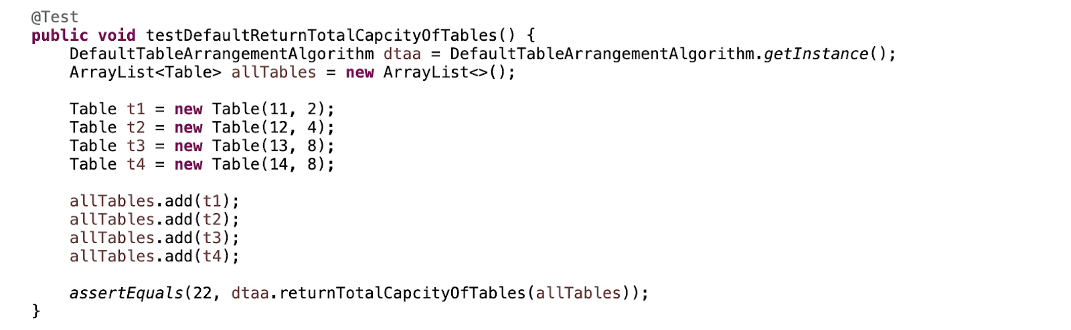

**Test 4:** Obtain the result of arrangement for default arrangement successfully

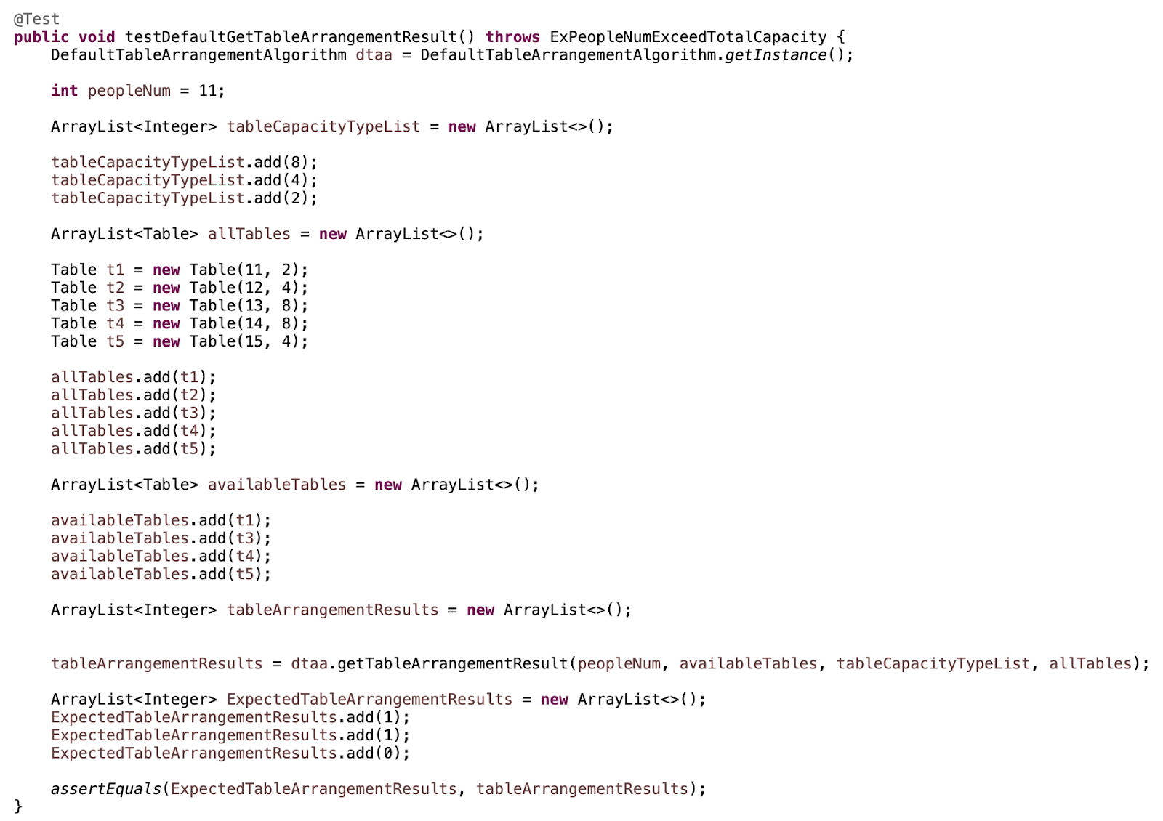

**Test 5:**

Obtain the result of arrangement for default arrangement when the last table capacity type, i.e., the capacity of 2, available can fit all the people in the inputted number of people

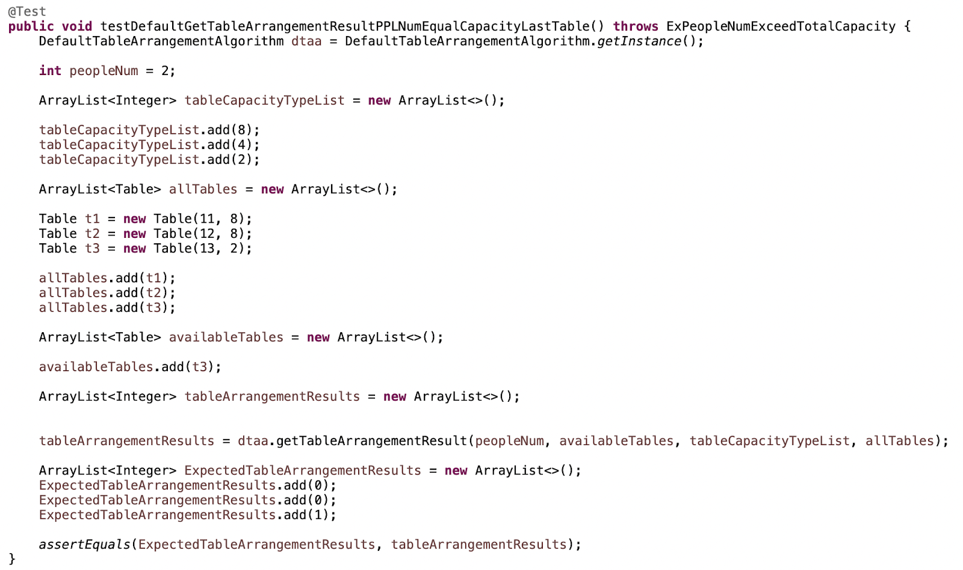

**Test 6:**

Obtain the result of arrangement for default arrangement when the table capacity available can fit all the people in the inputted number of people and the table is not the last table capacity

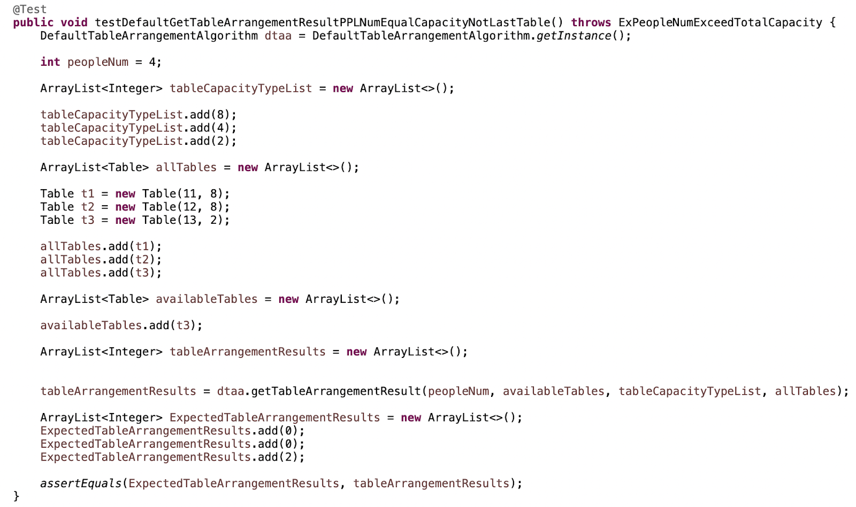

**Test 7:**

Obtain the result of arrangement for default arrangement when the table capacity available can fit all the people in the inputted number of people and the table is not the last table capacity

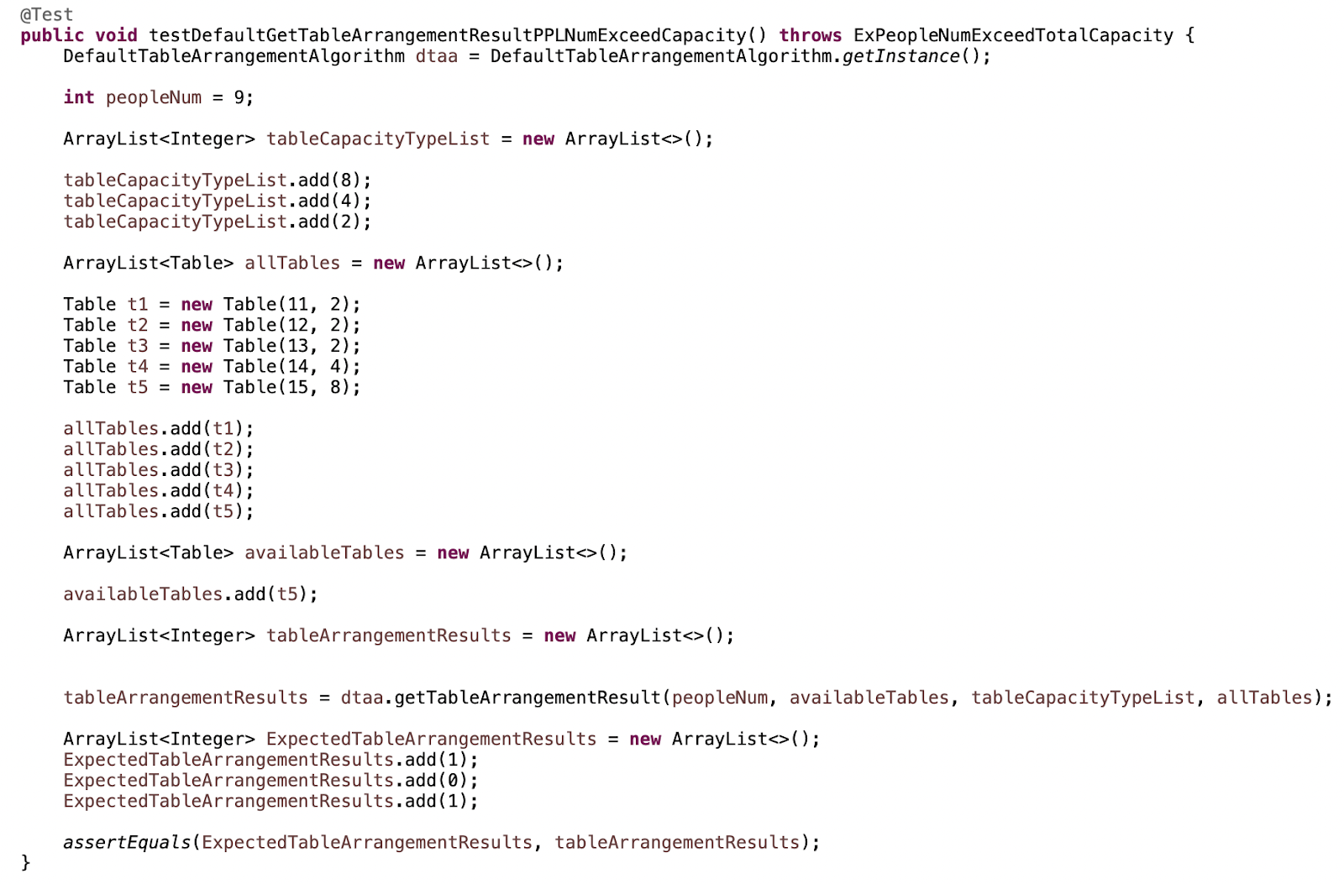

#### 4.1.5.2 Recommended Arrangement

Branch Coverage:

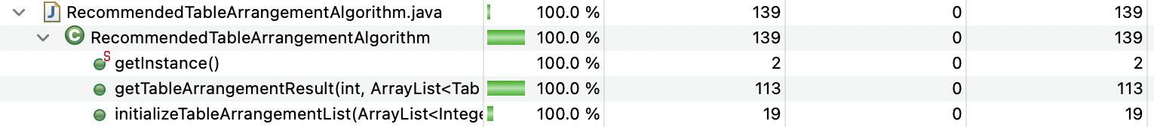

**Test 1:** Initializing Table Arrangement List

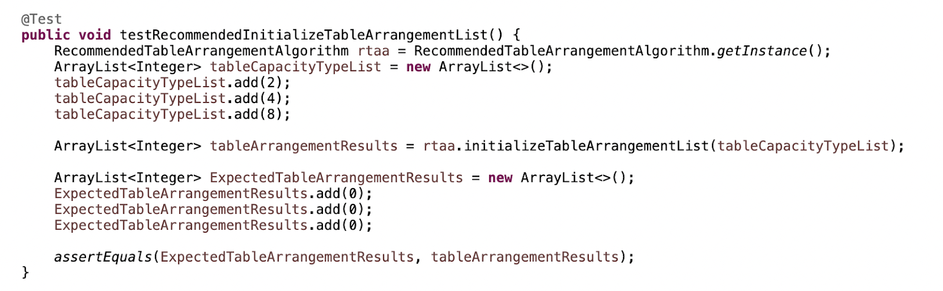

**Test 2:** Obtain the optimized arrangement (recommended arrangement) result successfully

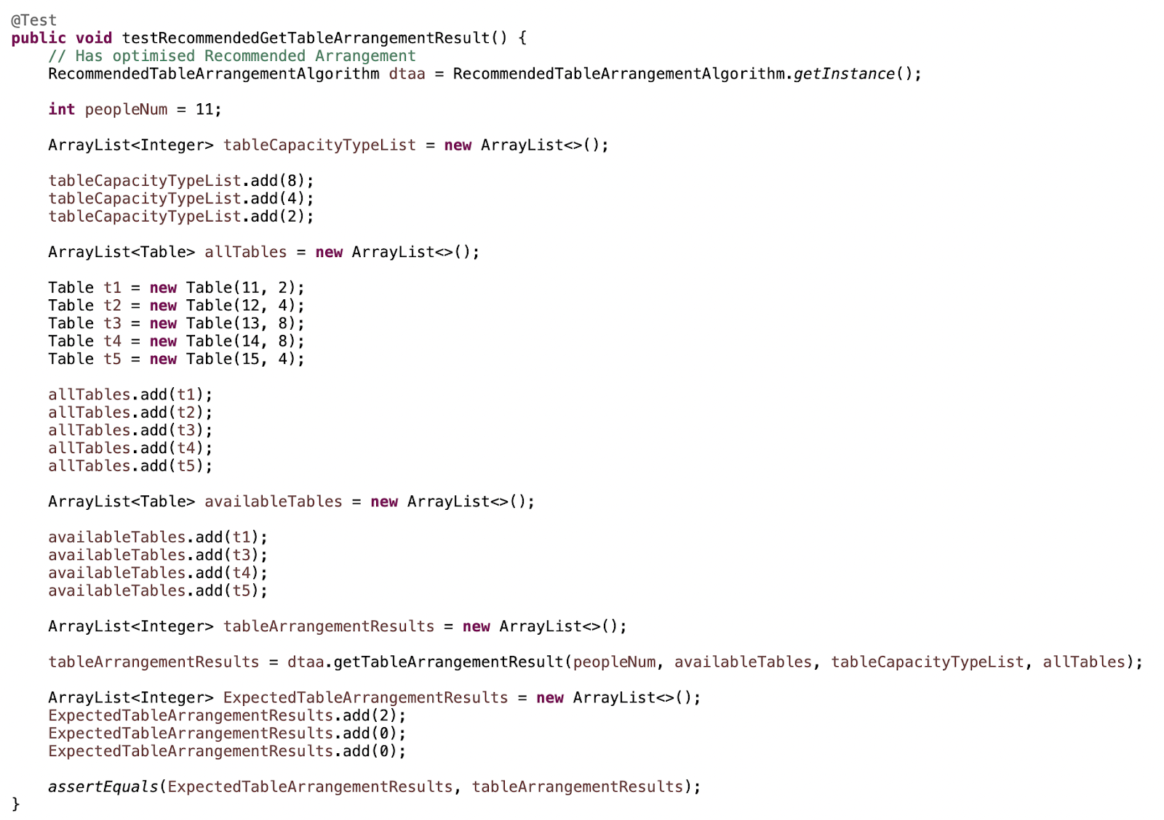

**Test 3:** No optimized arrangement

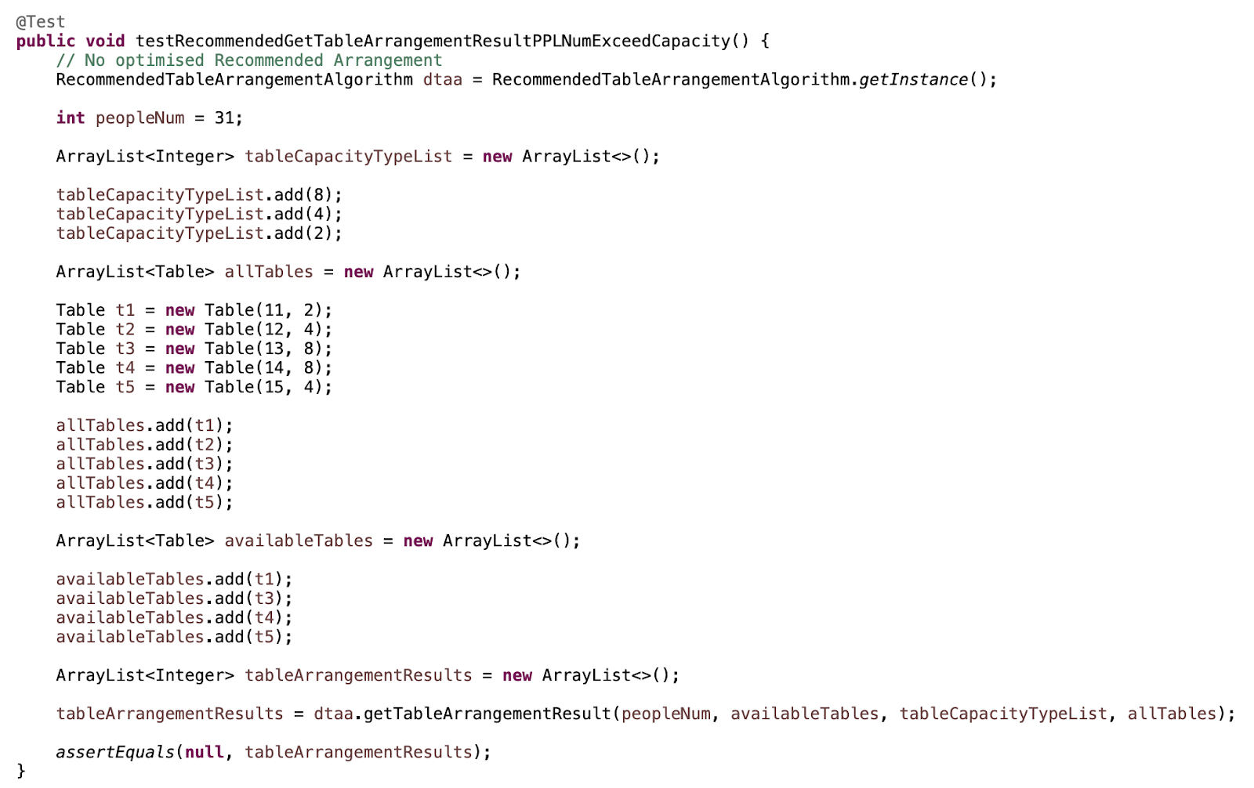

**4.2 Black-Box Testing**

Advantage of Black-Box testing:

* The test is unbiased because the designer and the tester are independent of each other.
* The tester does not need knowledge of any specific programming languages.
* The test is done from the point of view of the user, not the designer.
* Test cases can be designed as soon as the specifications are complete.

**4.2.1 Sample Test Cases**

Test Case 1:

* Input: Super VIP, Dine-in, Pepper-Lunch, {Pork, Turkey}, Wechat Pay

|  |  |  |  |  |  |  |  |
| --- | --- | --- | --- | --- | --- | --- | --- |
| 1 | 1 | 2 | 1 | 3 | 2 | 3 | 2 |

* Output: $86.24, “You will be redirected to WeChat to continue payment.”

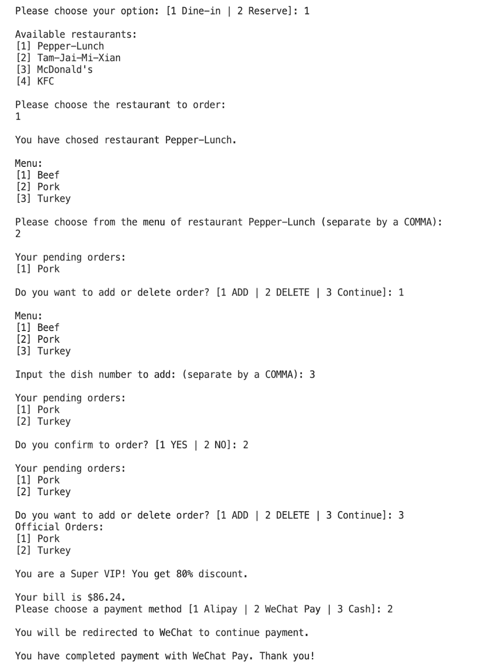

Test Case 2:

* Input: Member, Dine-in, KFC, { Beef-Egg-Burger, Beef-Egg-Burger, Beef-Egg-Burger}, Wechat Pay

|  |  |  |  |  |  |  |  |
| --- | --- | --- | --- | --- | --- | --- | --- |
| 1 | 1 | 2 | 1 | 3 | 2 | 3 | 2 |

* Output: $86.24, “You will be redirected to WeChat to continue payment.”

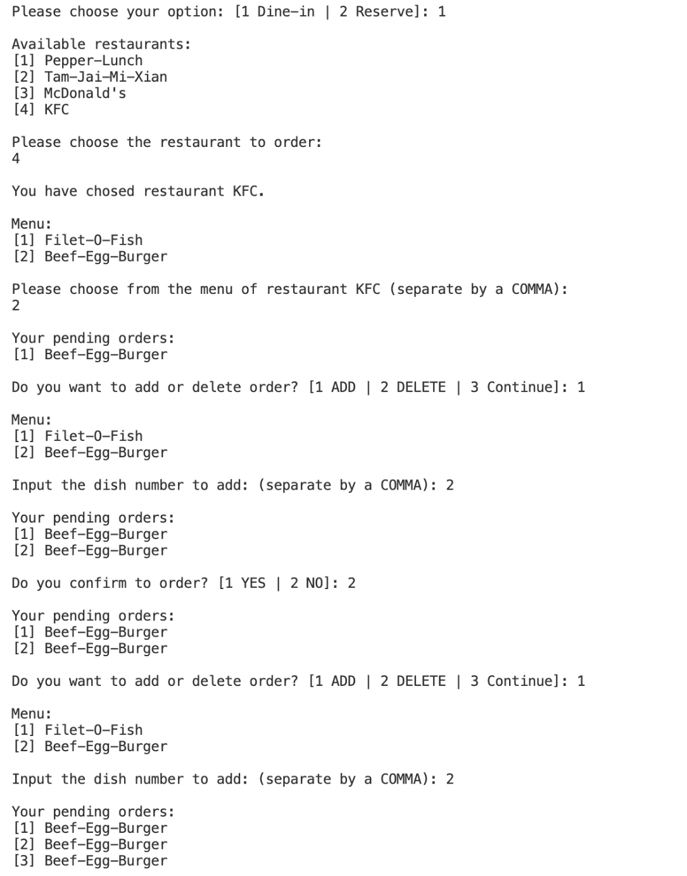

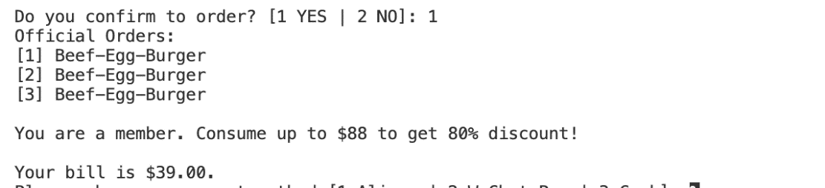

**4.2.2 Invalid Input**

#### 4.2.2.1 Invalid Input 1: Integer out of given choice

Example 1:

* Input: 3
* Expected output: Ask for valid input again.
* Actual output:

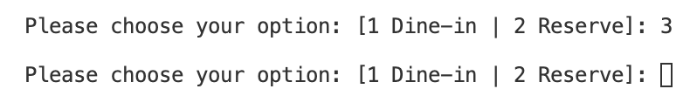

Example 2:

* Input: 5
* Expected output:  Ask for valid restaurant input again.
* Actual output:

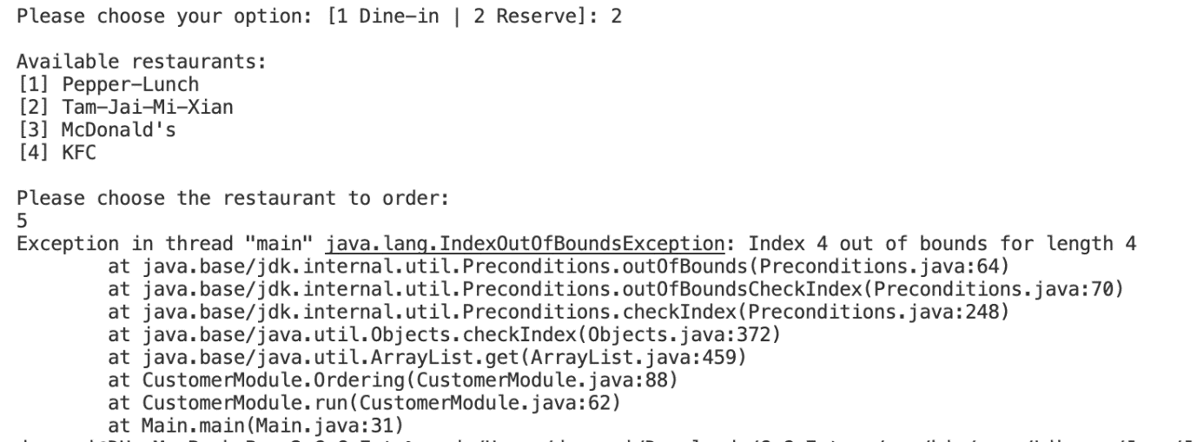

#### 4.2.2.2 Invalid Input 2: Not an integer

Example 1:

* Input: 1.5
* Expected output: Ask for an integer.
* Actual output: Error

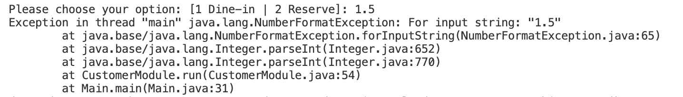

Example 2:

* Input: a
* Expected output: Ask for an integer.
* Actual output: Error

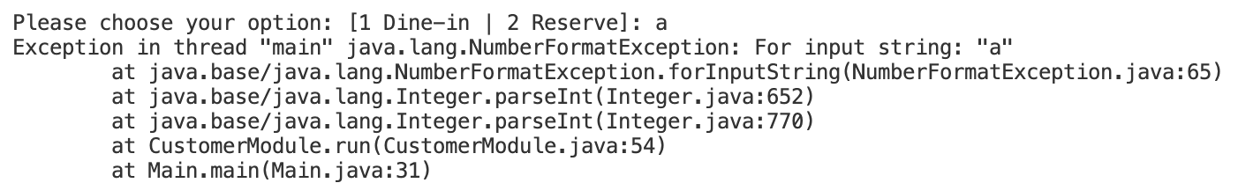

**5. System Test**

**5.1 Testing Approach**

The testing approach we adopted for system testing is Category-Partition Method (CPM) in Black-box Testing. The restrictions for test cases are written in Test Specification Language, then we write test cases based on the TSL.

By using Category-Partition Method (CPM), we firstly analyze the specification to identify the individual testable function units, parameters of the function units, and entities in environment which affect operation. Secondly we classify the specifications into categories and partition the categories into choices. Thirdly we determine the constraints among the choices, for example, how one choice in one category affect the other choices the another category. Then we write and process the test specification, and express them in TSL. Next, we evaluate the expect output of each test frame. Finally we convert the test frames into test cases.

In the below part of system test, we will divide the system test by different login in identities, which are customer, merchant, and admin. And for each identity, the testing TSL, test frames and test cases will be shown in detail.

**5.2 Test Cases for System Testing**

**5.2.1 Customer**

**5.2.1.1 Customer TSL**

*Service:*

Dine In                    [property dine in]

Reservation         [property reservation]

Cancel Reservation    [property cancel]

Log Out                      [property logout]

*Reserved:*

Reserved           [property isReserved]

No reservation        [property noReserved]

*Choose Table:*

Valid table          [if dine in & noReserved] [property have table]

Invalid table        [if dine in & noReserved] [property no table]

*Action:*

Walk in            [if isReserved or have table] [property walk in]

Leave                [if dine in]

Queue              [if no table]

*Restaurant:*

Pepper – Lunch  [if walk in]

Tam-Jai-Mi-Xian [if walk in]

McDonald’s         [if walk in]

KFC                           [if walk in]

*Reserve Time:*

Valid time                [if reservation & noReserved]

Invalid time           [if reservation & noReserved]

**5.2.1.2 Customer Test Frames**

|  |  |  |  |  |  |  |  |  |
| --- | --- | --- | --- | --- | --- | --- | --- | --- |
|  | **Service** | **Reserved** | **Choose**  **Table** | **Action** | **Restaurant** | **Reserve**  **Time** | **Dish** | **Expect**  **Behaviour** |
| 1 | Cancel Reservation | Reserved | / | / | / | / | / | Cancel Success! |
| 2 | Reservation | No  reservation | / | / | / | Valid  Time | / | Reserve Success.  And Reservation Reminder |
| 3 | Reservation | No  reservation | / | / | / | Invalid  Time | / | Invalid Time Slot!  And ask to retry. |
| 4 | Dine in | Reserved | / | Walk in | KFC | / | … | Return the bill  and bill number. |
| 5 | Dine in | Reserved | / | Walk in | Tam-Jai  -Mi-Xian | / | … | Return the bill  and bill number. |
| 6 | Dine in | Reserved | / | Walk in | McDonald’s | / | … | Return the bill  and bill number. |
| 7 | Dine in | Reserved | / | Walk in | Pepper  -Lunch | / | … | Return the bill  and bill number. |
| 8 | Dine in | No  reservation | Valid  table | Walk in | Tam-Jai  -Mi-Xian | / | … | Return the bill  and bill number. |
| 9 | Dine in | No  reservation | Valid   table | Walk in | KFC | / | … | Return the bill  and bill number. |
| 10 | Dine in | No  reservation | Valid   table | Walk in | McDonald’s | / | … | Return the bill  and bill number. |
| 11 | Dine in | No  reservation | Valid   table | Walk in | Pepper  -Lunch | / | … | Return the bill  and bill number. |
| 12 | Dine in | No  reservation | Valid   table | Leave | / | / | / | Check out to the command bar. |
| 13 | Dine in | No  reservation | Invalid   table | Leave | / | / | / | Check out to the command bar. |
| 14 | Dine in | No  reservation | Invalid   table | Queue | / | / | / | Return the  waiting number. |

**5.2.1.3 Coverage**

*Coverage: 100%*

We manually list out all valid combinations of parameters “Service”, “Reserved”, “Choose Table”, “Action”, “Restaurant”, and “Reserve Time”.

**5.2.1.4 Test Cases and Actual Output**

**Test Case 1:**

|  |  |  |  |  |  |  |  |  |
| --- | --- | --- | --- | --- | --- | --- | --- | --- |
|  | **Service** | **Reserved** | **Choose**  **Table** | **Action** | **Restaurant** | **Reserve**  **Time** | **Dish** | **Expect Behaviour** |
| 1 | Cancel  Reservation | Reserved | / | / | / | / | / | Cancel Success! |

**Actual Output of Test Case 1:**

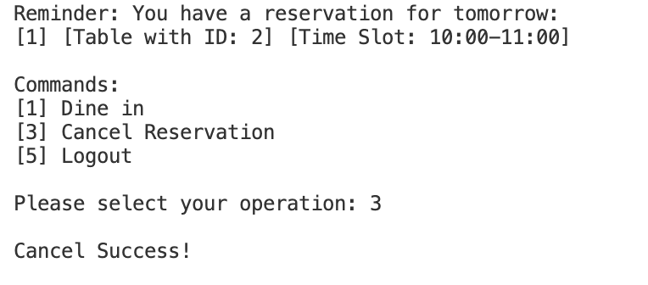

**Test Case 2:**

|  |  |  |  |  |  |  |  |  |
| --- | --- | --- | --- | --- | --- | --- | --- | --- |
| 2 | Reservation | No  Reservation | / | / | / | Valid Time | / | Reserve Success.  And remind the reserved time. |

**Actual Output of Test Case 2:**

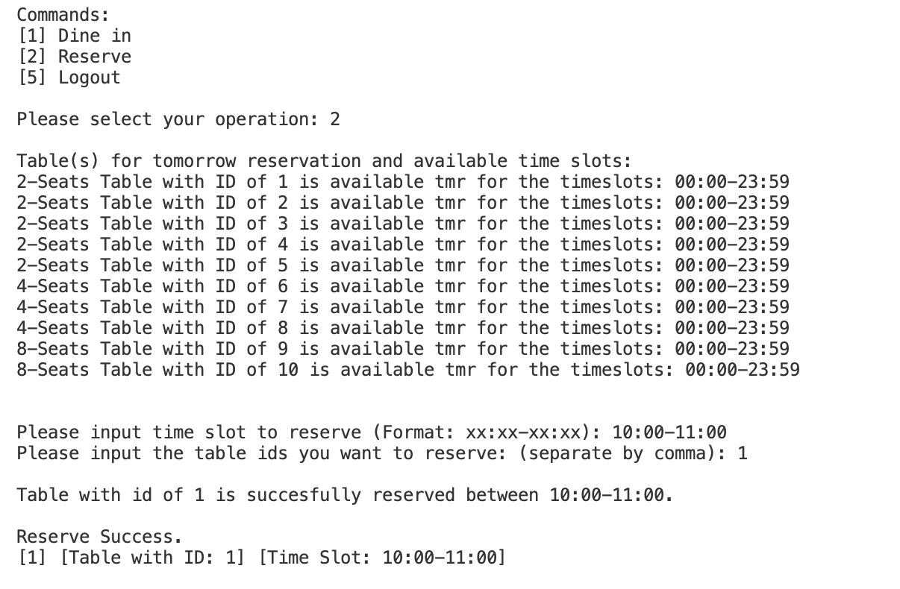

**Test Case 3:**

|  |  |  |  |  |  |  |  |  |
| --- | --- | --- | --- | --- | --- | --- | --- | --- |
| 3 | Reservation | No  Reservation | / | / | / | Invalid  Time | / | Invalid Time Slot!  And ask to retry |

**Actual Output of Test Case 3:**

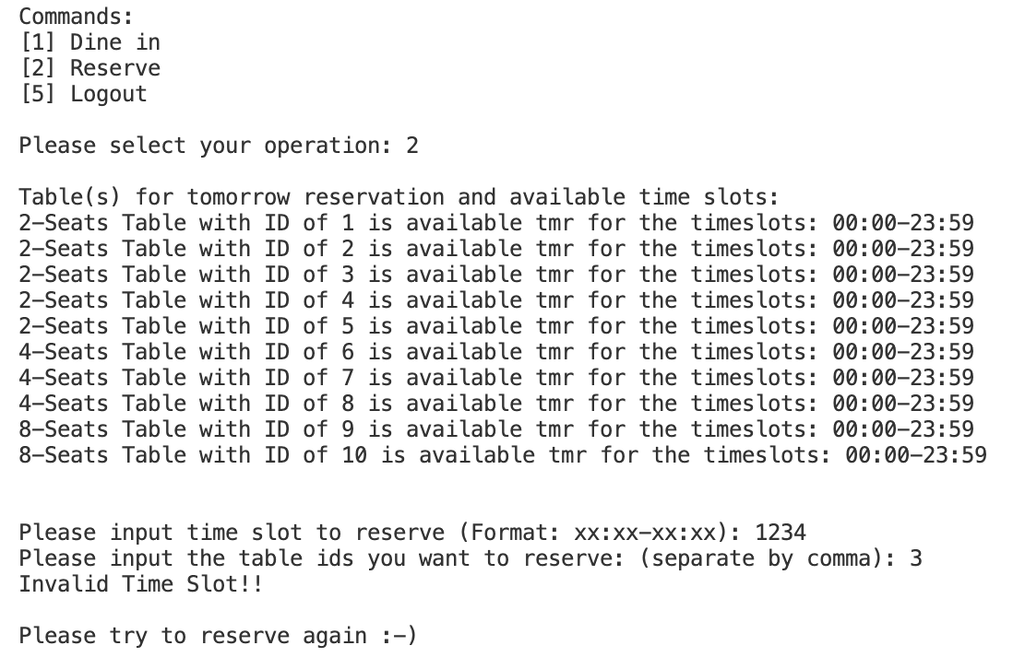

**Test Case 4:**

|  |  |  |  |  |  |  |  |  |
| --- | --- | --- | --- | --- | --- | --- | --- | --- |
| 4 | Dine in | Reserved/  No reservation | / | Walk in | A restaurant | / | Some  dish | Return the bill  and bill number. |

**Actual Output of Test Case 4:**

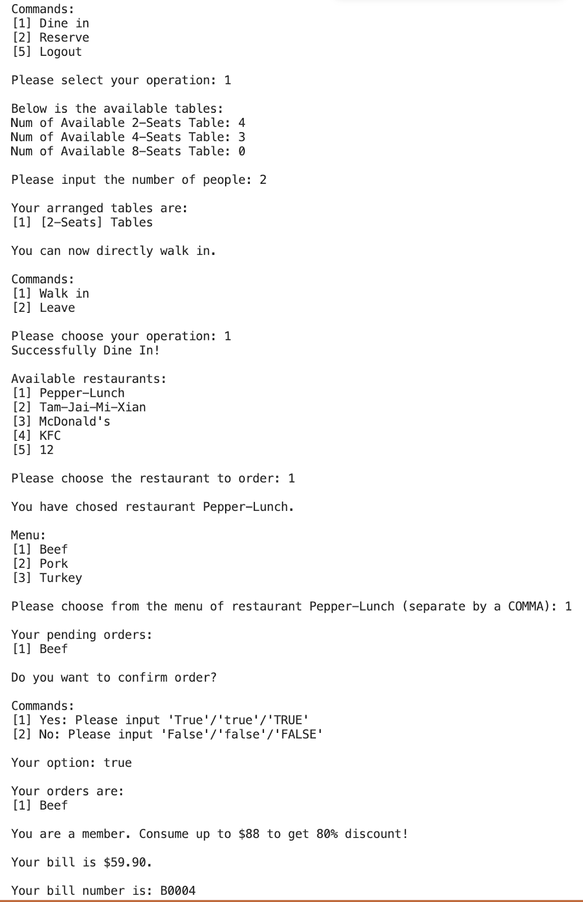

**Specific Cases for Dish**

|  |  |  |  |  |
| --- | --- | --- | --- | --- |
| Restaurant | Dish | Membership | Expected  payment | Actual Price |
| Tam-Jai-Mi-Xian | [1] Lettuce-Mixian | VIP | $29.9 | $29.90 |
| Pepper-Lunch | [1] Beef  [2] Pork | SuperVIP | $91.84 | $91.84 |
| Pepper-Lunch | [1] Beef  [2] Pork | VIP | $91.84 | $91.84 |
| KFC | [1] Filet-O-Fish  [2] Filet-O-Fish | SuperVIP | $19.2 | $19.2 |
| Mcdonald’s | [1] Americano  [2] Latte  [3] Americano  [4] Latte | VIP | $72 | $72 |
| KFC | [1] Filet-O-Fish | VIP | $12 | $12 |
| Pepper-Lunch | [1] Turkey | VIP | $52.9 | $52.9 |
| KFC | [1] Filet-O-Fish  [2] Beef-Egg-Burger  [3] Beef-Egg-Burger  [4] Filet-O-Fish | VIP | $50 | $50 |
| Tam-Jai-Mi-Xian | [1] Lettuce-Mixian  [2] Lettuce-Mixian  [3] Lettuce-Mixian  [4] Pork-Mixian | SuperVIP | $99.68 | $99.68 |
| Mcdonald’s | [1] Hot-Chocolate  [2] Latte  [3] Americano  [4] Americano  [5] Americano  [6] Hot-Chocolate | SuperVIP | $83.2 | $83.2 |

**Test Case 5:**

|  |  |  |  |  |  |  |  |  |
| --- | --- | --- | --- | --- | --- | --- | --- | --- |
| 12 | Dine in | No  reservation | Valid   table | Leave | / | / | / | Check out to the command bar. |

**Actual Output of Test Case 5:**

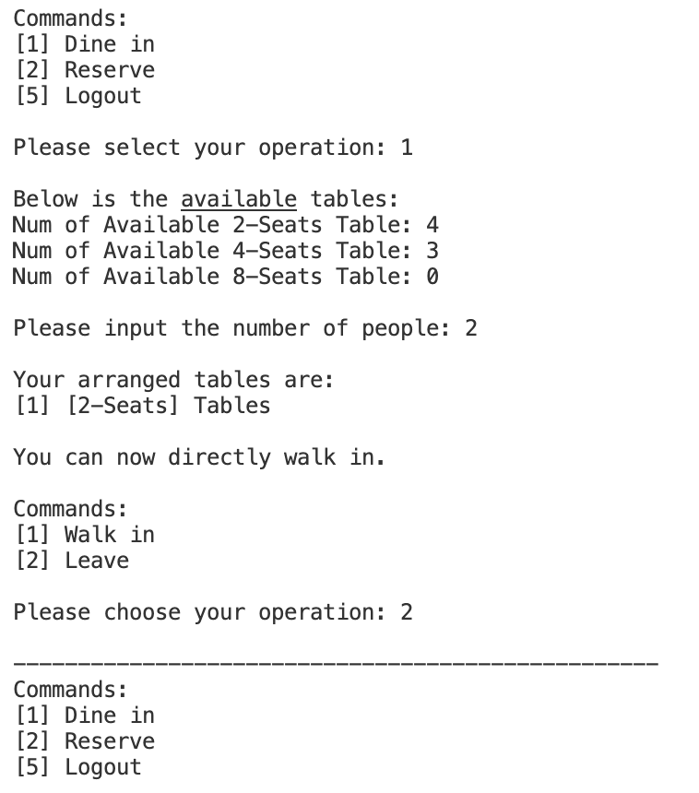

**Test Case 6:**

|  |  |  |  |  |  |  |  |  |
| --- | --- | --- | --- | --- | --- | --- | --- | --- |
| 13 | Dine in | No  reservation | Invalid   table | Leave | / | / | / | Check out to the command bar. |

**Actual Output of Test Case 6:**

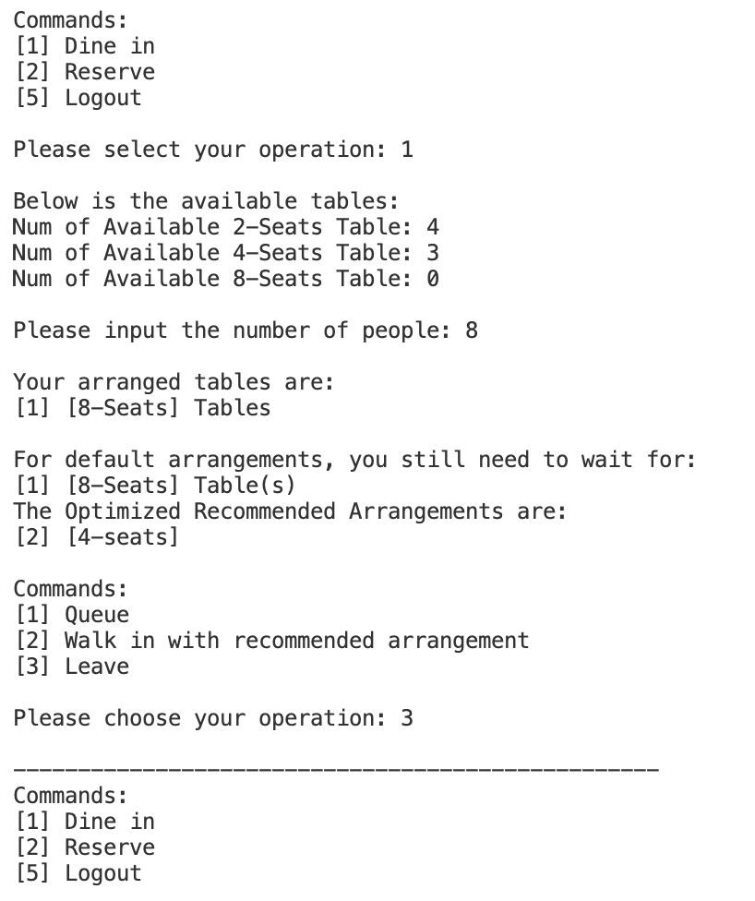

**Test Case 7:**

|  |  |  |  |  |  |  |  |  |
| --- | --- | --- | --- | --- | --- | --- | --- | --- |
| 14 | Dine in | No  reservation | Invalid   table | Queue | / | / | / | Return the  waiting number. |

**Actual Output of Test Case 7:**

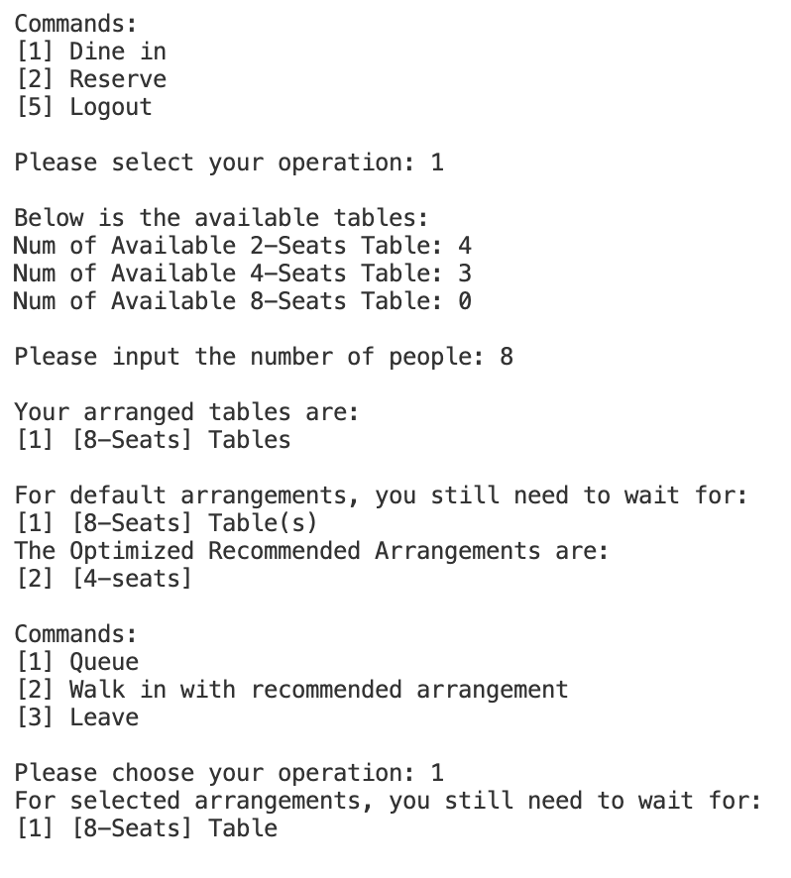

**5.2.2 Merchant**

**5.2.2.1 Merchant TSL**

*Service:*

Modify menu       [property modify]

Check order        [property check order]

Log out                       [property logout]

*Menu:*

Add dish              [if modify] [property add]

Remove dish       [if modify] [property remove]

Edit dish               [if modify] [property edit]

*Remove:*

Valid number    [if remove]

Invalid number  [if remove]

*Edit:*

Name                 [if edit] [property edit name]

Price               [if edit] [property edit price]

*Dish Name:*

Valid dish name    [if add or edit name]

Invalid dish name [if add or edit name]

*Dish Price:*

Valid price          [if add or edit price]

Invalid price       [if add or edit price]

*Customer ID:*

Existing ID         [if check order] [property id]

Invalid ID          [if check order]

*Bill:*

Have bill             [if id]

No bill                [if id]

**5.2.2.2 Merchant Test Frames**

|  |  |  |  |  |  |  |  |  |  |
| --- | --- | --- | --- | --- | --- | --- | --- | --- | --- |
|  | Service | Menu | Remove | Edit | Dish Name | Dish Price | Customer ID | Bill | Expect Behaviour |
| 1 | Modify Menu | Add dish | / | / | Valid | Valid | / | / | Add dish success. |
| 2 | Modify Menu | Edit Dish | / | Price | / | Valid | / | / | Edit dish success. |
| 3 | Check Order | / | / | / | / | / | Existing ID | Have bill | Return the bill. |
| 4 | Modify Menu | Add dish | / | / | Invalid | Valid | / | / | Ask for dish name again. |
| 5 | Check Order | / | / | / | / | / | Existing ID | No bill | Cannot find the bill. |
| 6 | Modify Menu | Add dish | / | / | Invalid | Invalid | / | / | Ask for the dish name and price again. |
| 7 | Modify Menu | Edit Dish | / | Price | / | Invalid | / | / | Ask for the dish price again. |
| 8 | Modify Menu | Remove dish | Valid number | / | / | / | / | / | Remove dish success. |
| 9 | Modify Menu | Edit Dish | / | Name | Valid | / | / | / | Edit dish success. |
| 10 | Check Order | / | / | / | / | / | Invalid ID | No bill | Ask for the customer id again. |
| 11 | Check Order | / | / | / | / | / | Invalid ID | Have bill | Ask for the customer id again. |
| 12 | Modify Menu | Add dish | / | / | Valid | Invalid | / | / | Ask for the dish price again. |
| 13 | Modify Menu | Remove dish | Invalid number | / | / | / | / | / | Ask for the dish number again. |
| 14 | Modify Menu | Edit Dish | / | Name | Invalid | / | / | / | Ask for the dish name again. |

**5.2.2.3 Triple Wise Coverage**

Tests: 14

Number of Possible Tests : 30

Coverage : 100%

Valid combinations of 3 values :

* covered : 414
* total : 414
* uncovered : 0

**5.2.2.4 Test Cases and Actual Output**

**Test Case 1:**

|  |  |  |  |  |  |  |  |  |  |
| --- | --- | --- | --- | --- | --- | --- | --- | --- | --- |
|  | **Service** | **Menu** | **Remove** | **Edit** | **Dish Name** | **Dish Price** | **Customer ID** | **Bill** | **Expect Behaviour** |
| 1 | Modify Menu | Add dish | / | / | Valid | Valid | / | / | Add dish success. |

**Actual Output of Test Case 1:**

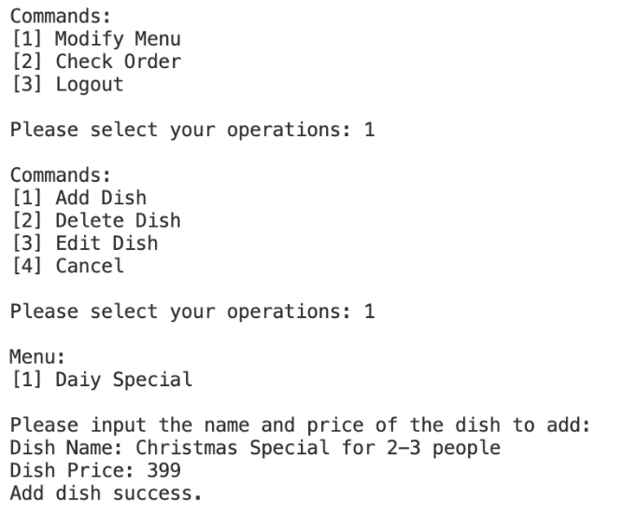

**Test Case 2:**

|  |  |  |  |  |  |  |  |  |  |
| --- | --- | --- | --- | --- | --- | --- | --- | --- | --- |
| 2 | Modify Menu | Edit Dish | / | Price | / | Valid | / | / | Edit dish success. |

**Actual Output of Test Case 2:**

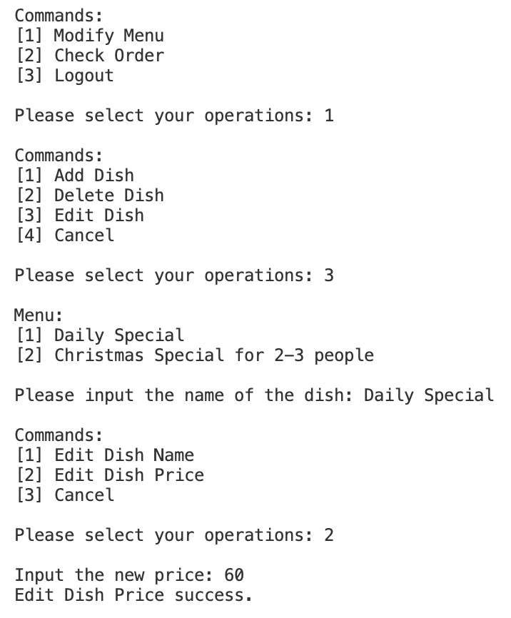

**Test Case 3:**

|  |  |  |  |  |  |  |  |  |  |
| --- | --- | --- | --- | --- | --- | --- | --- | --- | --- |
| 5 | Check Order | / | / | / | / | / | Existing ID | No bill | Cannot find the bill. |

**Actual Output of Test Case 3:**

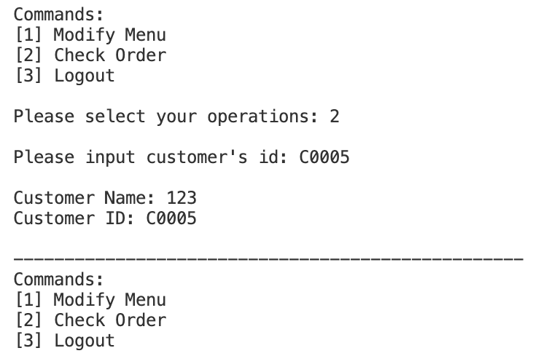

**Test Case 4:**

|  |  |  |  |  |  |  |  |  |  |
| --- | --- | --- | --- | --- | --- | --- | --- | --- | --- |
| 7 | Modify Menu | Edit Dish | / | Price | / | Invalid | / | / | Ask for the dish price again. |

**Actual Output of Test Case 4:**

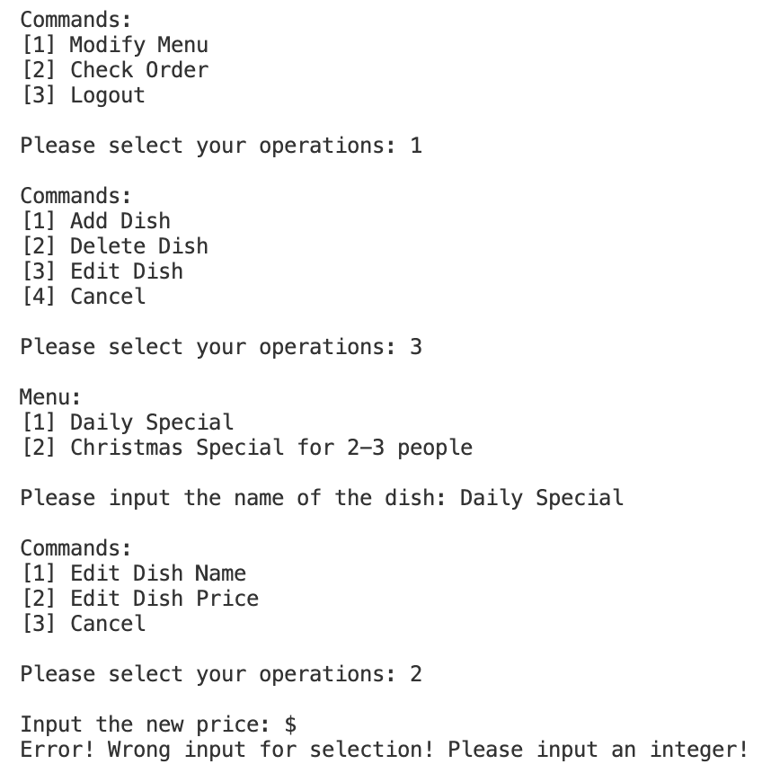

**Test Case 5:**

|  |  |  |  |  |  |  |  |  |  |
| --- | --- | --- | --- | --- | --- | --- | --- | --- | --- |
| 8 | Modify Menu | Remove dish | Valid number | / | / | / | / | / | Remove dish success. |

**Actual Output of Test Case 5:**

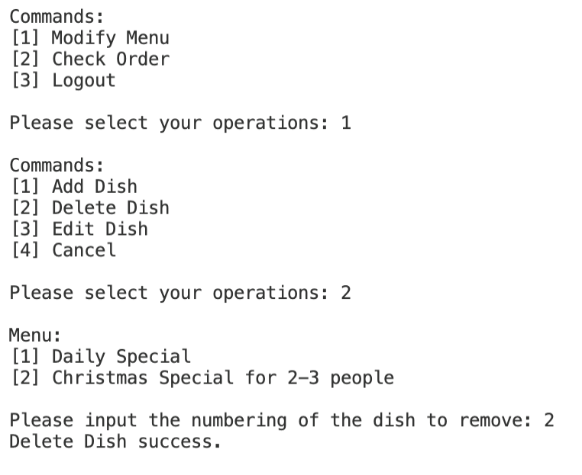

**Test Case 6:**

|  |  |  |  |  |  |  |  |  |  |
| --- | --- | --- | --- | --- | --- | --- | --- | --- | --- |
| 12 | Modify Menu | Add dish | / | / | Valid | Invalid | / | / | Ask for the dish price again. |

**Actual Output of Test Case 6:**

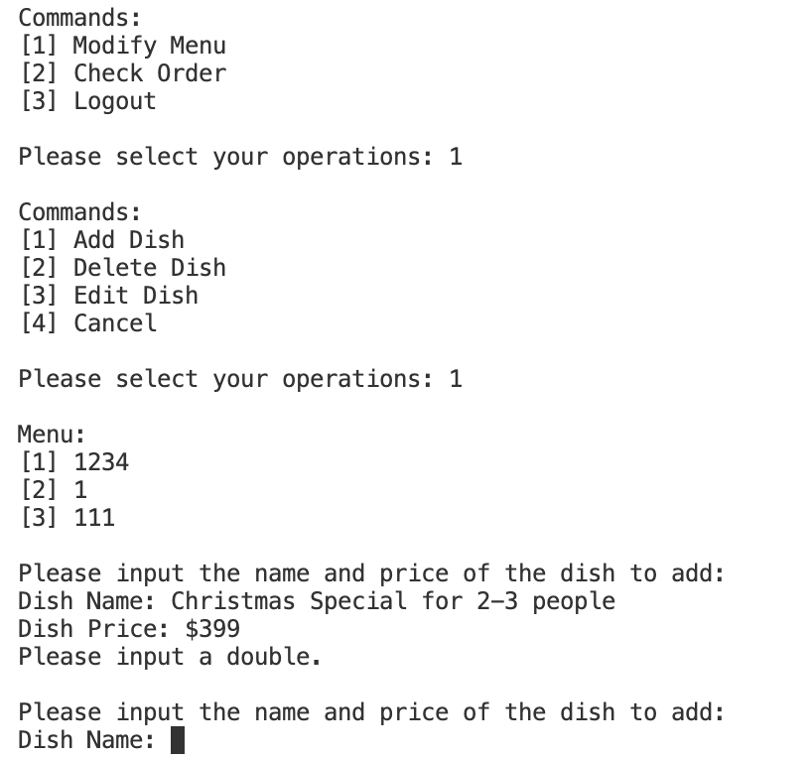

**Test Case 7:**

|  |  |  |  |  |  |  |  |  |  |
| --- | --- | --- | --- | --- | --- | --- | --- | --- | --- |
| 14 | Modify Menu | Edit Dish | / | Name | Invalid | / | / | / | Ask for the dish name again. |

**Actual Output of Test Case 7:**

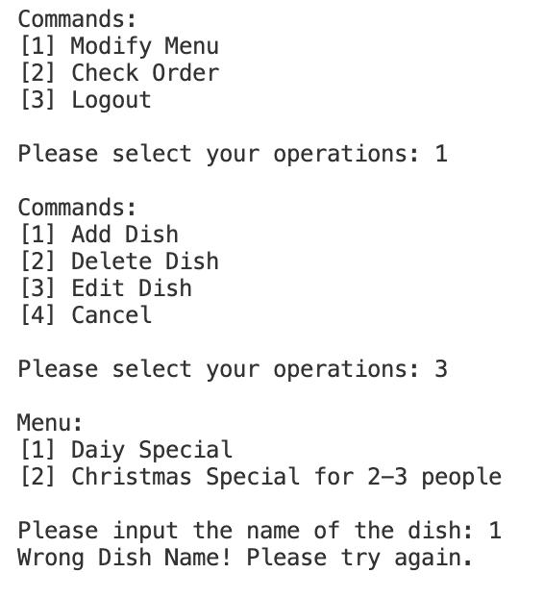

**5.2.3 Admin**

**5.2.3.1 Admin TSL**

*Service*:

         Change Opening Time            [Property Change Opening Hour]

         Check Order                       [Property Check]

         Check Reservation              [Property Check]

         Add Restaurant                   [Property Add Restaurant]

         Remove Restaurant             [Property Remove Restaurant]

         Add Table                           [Property Add]

         Remove Table                     [Property Remove]

         Log Out                               [single] [Property Log Out]

*Correct Input Format*

         Yes  [if Not Add Restaurant or Log Out]

         No   [error] [if Not Add Restaurant or Log Out]

*Time Overlap*

         Yes  [error] [if Change Opening Hour]

         No   [if Change Opening Hour]

*ID / Name Exists*

         Yes  [if Not Change Opening Hour or Log Out]

         No   [if Not Change Opening Hour or Log Out] [error]

*Match Found*

         Yes  [if Check]

         No   [if Check]

**5.2.3.2 Admin Test Frames**

|  |  |  |  |  |  |  |
| --- | --- | --- | --- | --- | --- | --- |
|  | **Service** | **Correct**  **Input Format** | **Time**  **Overlap** | **ID /**  **Name Exists** | **Match**  **Found** | **Expected Behavior** |
| 1 | Change  Opening Time | Yes | No | / | / | Change Success |
| 2 | Change  Opening Time | Yes | Yes | / | / | Change Fail,  ask for retry |
| 3 | Change  Opening Time | No | / | / | / | Change Fail,  ask for retry |
| 4 | Check Order | Yes | / | Yes | Yes | Print order info |
| 5 | Check Order | Yes | / | Yes | No | Order not found |
| 6 | Check Order | Yes | / | No | / | ID / Name not found,  ask for retry |
| 7 | Check Order | No | / | / | / | Invalid format,  ask for retry |
| 8 | Check  Reservation | Yes | / | Yes | Yes | Print reservation info |
| 9 | Check  Reservation | Yes | / | Yes | No | Reservation not found |
| 10 | Check  Reservation | Yes | / | No | / | ID / Name not found,  ask for retry |
| 11 | Check  Reservation | No | / | / | / | Invalid format,  ask for retry |
| 12 | Add Restaurant | / | / | / | / | Add success |
| 13 | Remove  Restaurant | Yes | / | Yes | / | Remove success |
| 14 | Remove  Restaurant | Yes | / | No | / | ID / Name not found,  ask for retry |
| 15 | Remove  Restaurant | No | / | / | / | Invalid format,  ask for retry |
| 16 | Add Table | Yes | / | Yes | / | Add Fail, duplicate  ID, ask for retry |
| 17 | Add Table | Yes | / | No | / | Add Success |
| 18 | Add Table | No | / | / | / | Invalid format,  ask for retry |
| 19 | Remove Table | Yes | / | Yes | / | Remove Success |
| 20 | Remove Table | Yes | / | No | / | ID not found,  ask for retry |
| 21 | Remove Table | No | / | / | / | Invalid format,  ask for retry |
| 22 | Log Out | / | / | / | / | Logged out |

**5.2.3.3 Coverage**

*Coverage: 100%*

We manually list out all valid combinations of parameters “Service”, “Correct Input Format”, “Time Overlap”, “ID / Name Exists”, “Match Found”

**5.2.3.4 Test Cases and Actual Output**

**Test Case 1:**

|  |  |  |  |  |  |  |
| --- | --- | --- | --- | --- | --- | --- |
|  | **Service** | **Correct**  **Input Format** | **Time**  **Overlap** | **ID /**  **Name Exists** | **Match**  **Found** | **Expected Behavior** |
| 1 | Change  Opening Time | Yes | No | / | / | Change Success |

**Actual Output of Test Case 1:**

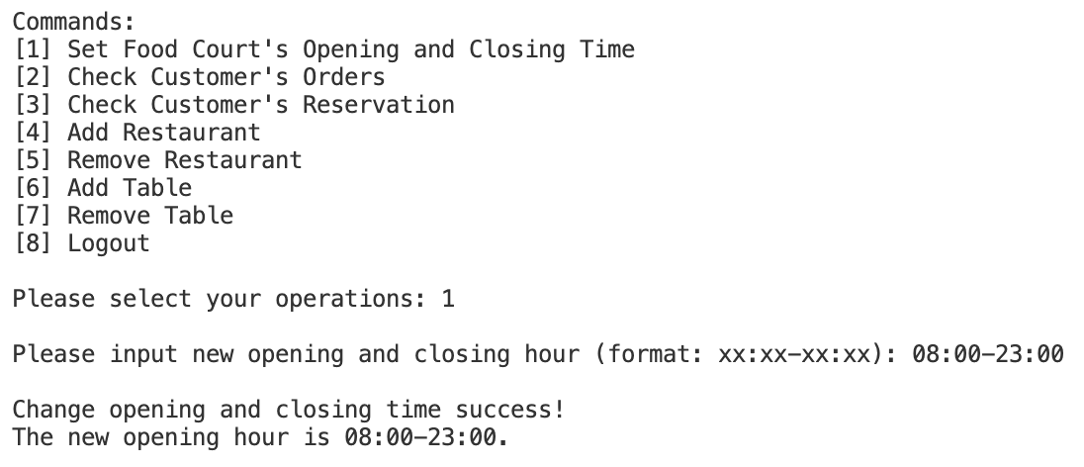

**Test Case 2:**

|  |  |  |  |  |  |  |
| --- | --- | --- | --- | --- | --- | --- |
| 3 | Change  Opening Time | No | / | / | / | Change Fail,  ask for retry |

**Actual Output of Test Case 2:**

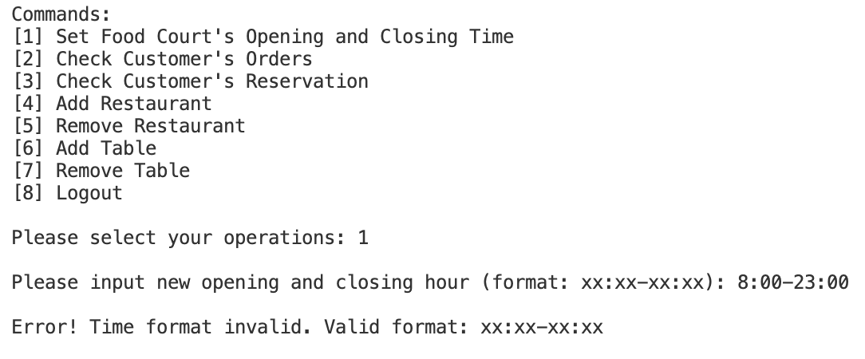

**Test Case 3:**

|  |  |  |  |  |  |  |
| --- | --- | --- | --- | --- | --- | --- |
| 4 | Check Order | Yes | / | Yes | Yes | Print order info |

**Actual Output of Test Case 3:**

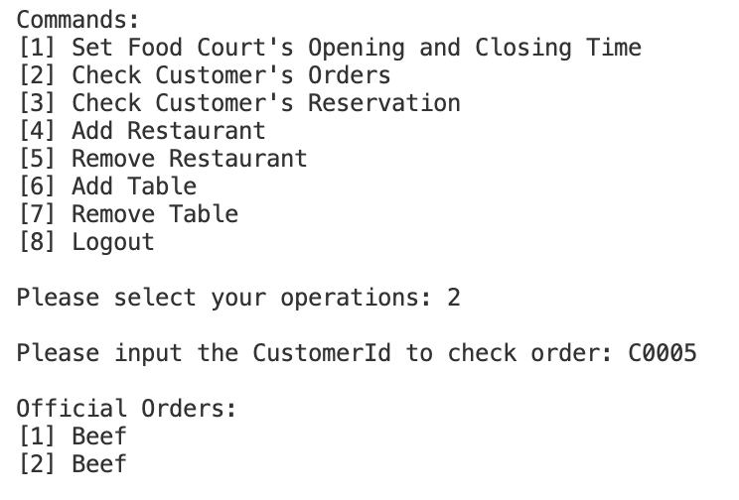

**Test Case 4:**

|  |  |  |  |  |  |  |
| --- | --- | --- | --- | --- | --- | --- |
| 5 | Check Order | Yes | / | Yes | No | Order not found |

**Actual Output of Test Case 4:**

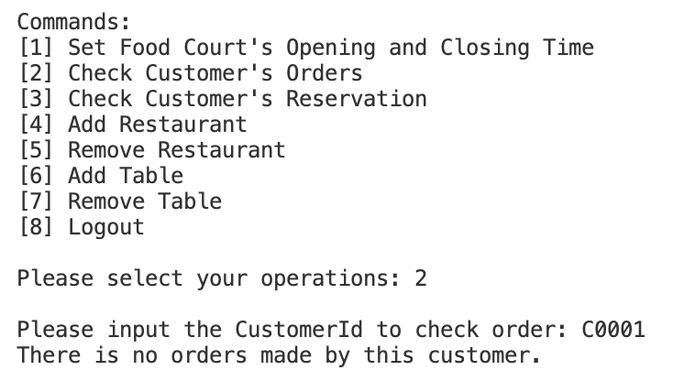

**Test Case 5:**

|  |  |  |  |  |  |  |
| --- | --- | --- | --- | --- | --- | --- |
| 6 | Check Order | Yes | / | No | / | ID / Name not found,  ask for retry |

**Actual Output of Test Case 5:**

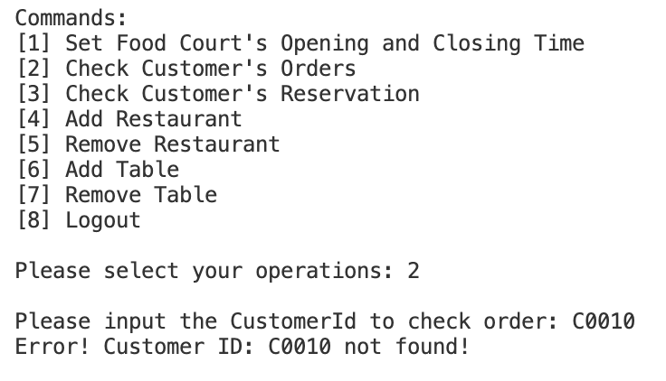

**Test Case 6:**

|  |  |  |  |  |  |  |
| --- | --- | --- | --- | --- | --- | --- |
| 7 | Check Order | No | / | / | / | Invalid format,  ask for retry |

**Actual Output of Test Case 6:**

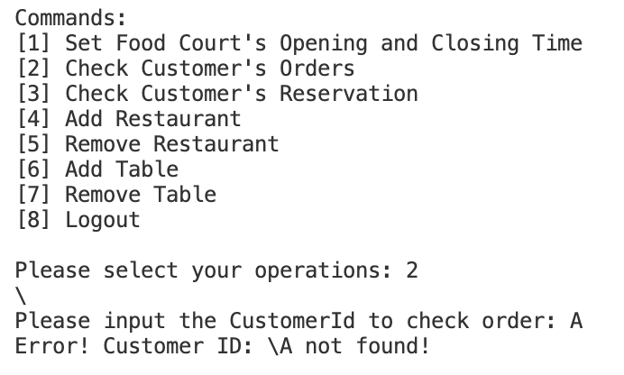

**Test Case 7:**

|  |  |  |  |  |  |  |
| --- | --- | --- | --- | --- | --- | --- |
| 8 | Check  Reservation | Yes | / | Yes | Yes | Print reservation info |

**Actual Output of Test Case 7:**

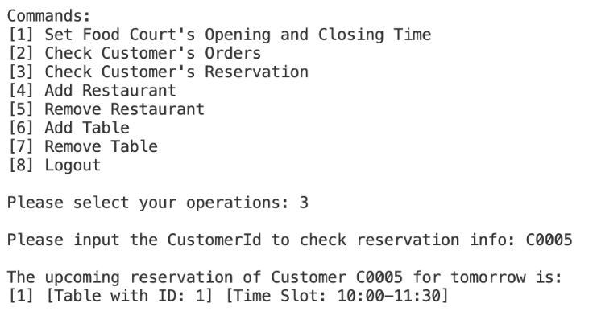

**Test Case 8:**

|  |  |  |  |  |  |  |
| --- | --- | --- | --- | --- | --- | --- |
| 9 | Check  Reservation | Yes | / | Yes | No | Reservation not found |

**Actual Output of Test Case 8:**

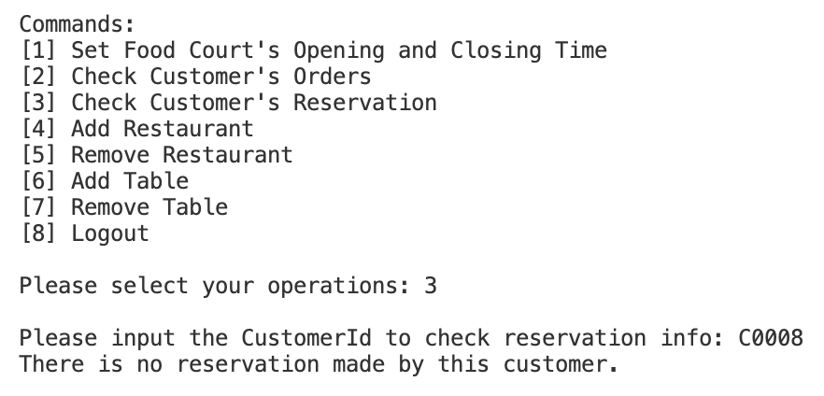

**Test Case 9:**

|  |  |  |  |  |  |  |
| --- | --- | --- | --- | --- | --- | --- |
| 10 | Check  Reservation | Yes | / | No | / | ID / Name not found,  ask for retry |

**Actual Output of Test Case 9:**

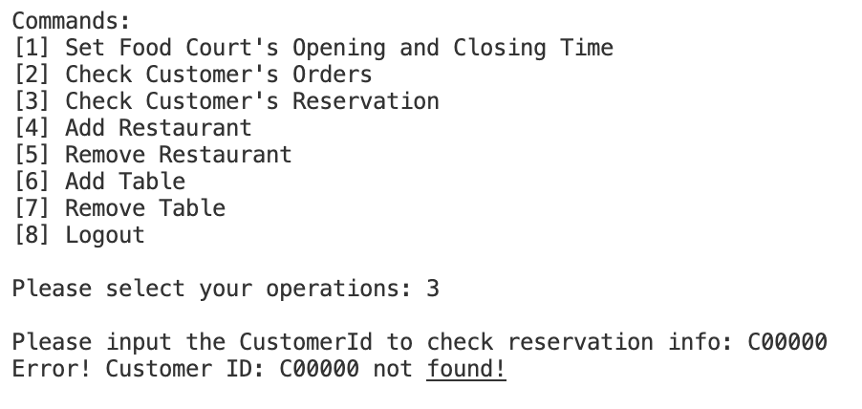

**Test Case 10:**

|  |  |  |  |  |  |  |
| --- | --- | --- | --- | --- | --- | --- |
| 11 | Check  Reservation | No | / | / | / | Invalid format,  ask for retry |

**Actual Output of Test Case 10:**

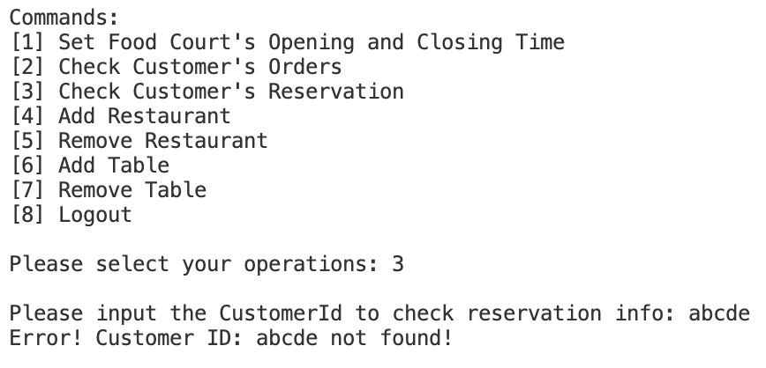

**Test Case 11:**

|  |  |  |  |  |  |  |
| --- | --- | --- | --- | --- | --- | --- |
| 12 | Add Restaurant | / | / | / | / | Add success |

**Actual Output of Test Case 11:**

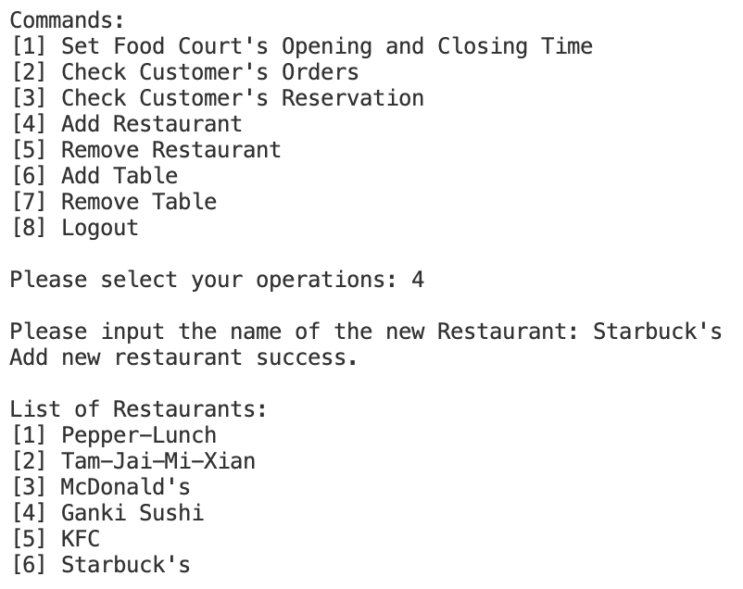

**Test Case 12:**

|  |  |  |  |  |  |  |
| --- | --- | --- | --- | --- | --- | --- |
| 13 | Remove  Restaurant | Yes | / | Yes | / | Remove success |

**Actual Output of Test Case 12:**

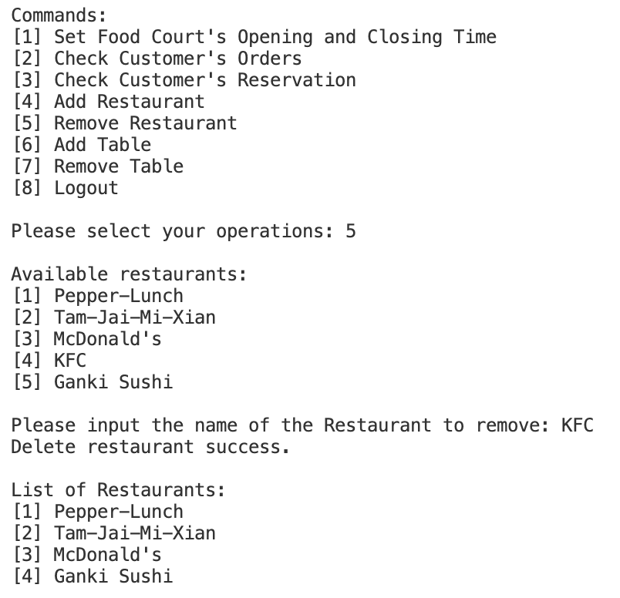

**Test Case 13:**

|  |  |  |  |  |  |  |
| --- | --- | --- | --- | --- | --- | --- |
| 15 | Remove  Restaurant | No | / | / | / | Invalid format,  ask for retry |

**Actual Output of Test Case 13:**

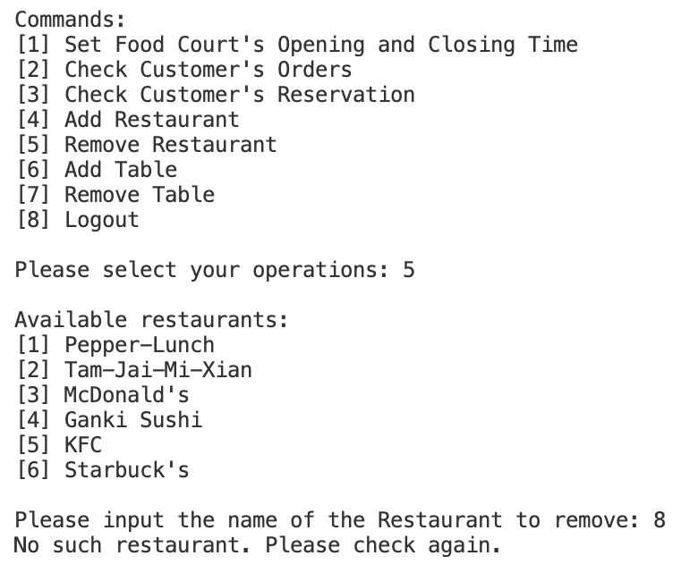

**Test Case 14:**

|  |  |  |  |  |  |  |
| --- | --- | --- | --- | --- | --- | --- |
| 16 | Add Table | Yes | / | Yes | / | Add Fail, duplicate  ID, ask for retry |

**Actual Output of Test Case 14:**

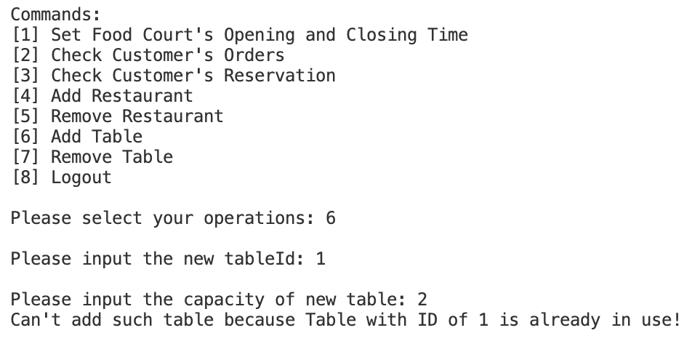

**Test Case 15:**

|  |  |  |  |  |  |  |
| --- | --- | --- | --- | --- | --- | --- |
| 17 | Add Table | Yes | / | No | / | Add Success |

**Actual Output of Test Case 15:**

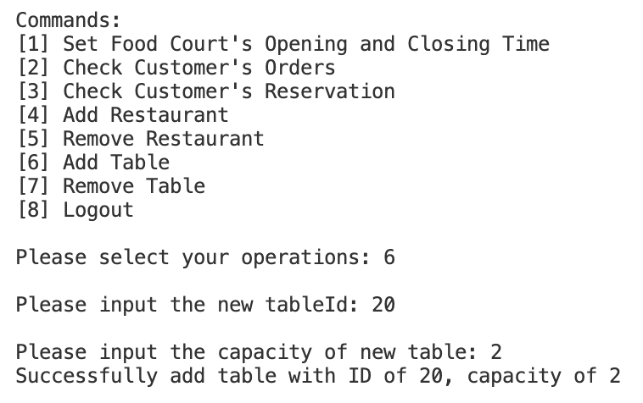

**Test Case 16:**

|  |  |  |  |  |  |  |
| --- | --- | --- | --- | --- | --- | --- |
| 18 | Add Table | No | / | / | / | Invalid format,  ask for retry |

**Actual Output of Test Case 16:**

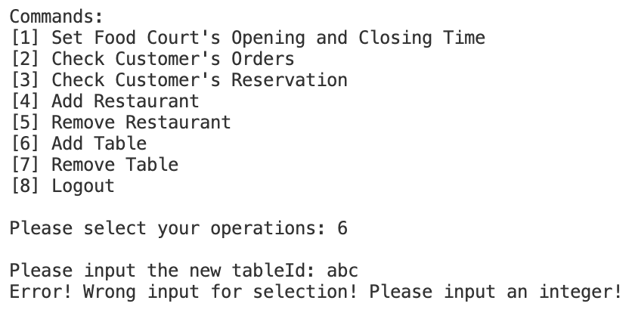

**Test Case 17:**

|  |  |  |  |  |  |  |
| --- | --- | --- | --- | --- | --- | --- |
| 19 | Remove Table | Yes | / | Yes | / | Remove Success |

**Actual Output of Test Case 17:**

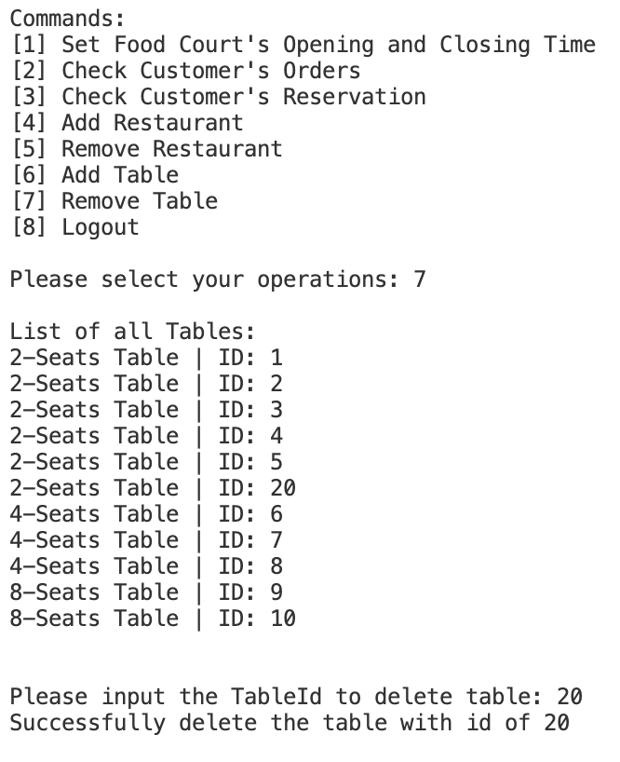

**Test Case 18:**

|  |  |  |  |  |  |  |
| --- | --- | --- | --- | --- | --- | --- |
| 20 | Remove Table | Yes | / | No | / | ID not found,  ask for retry |

**Actual Output of Test Case 18:**

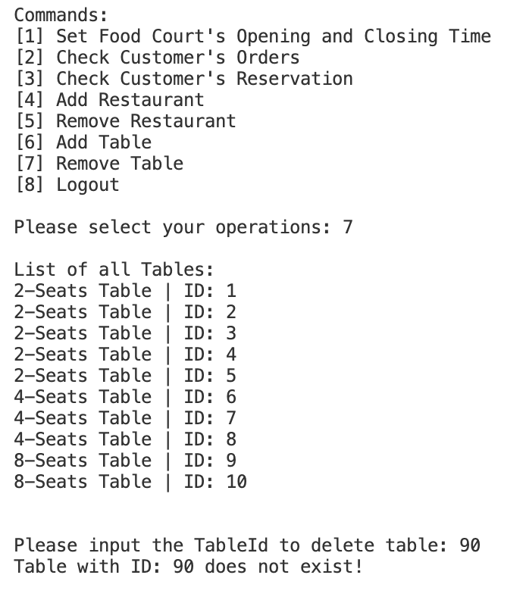

**Test Case 19:**

|  |  |  |  |  |  |  |
| --- | --- | --- | --- | --- | --- | --- |
| 21 | Remove Table | No | / | / | / | Invalid format,  ask for retry |

**Actual Output of Test Case 19:**

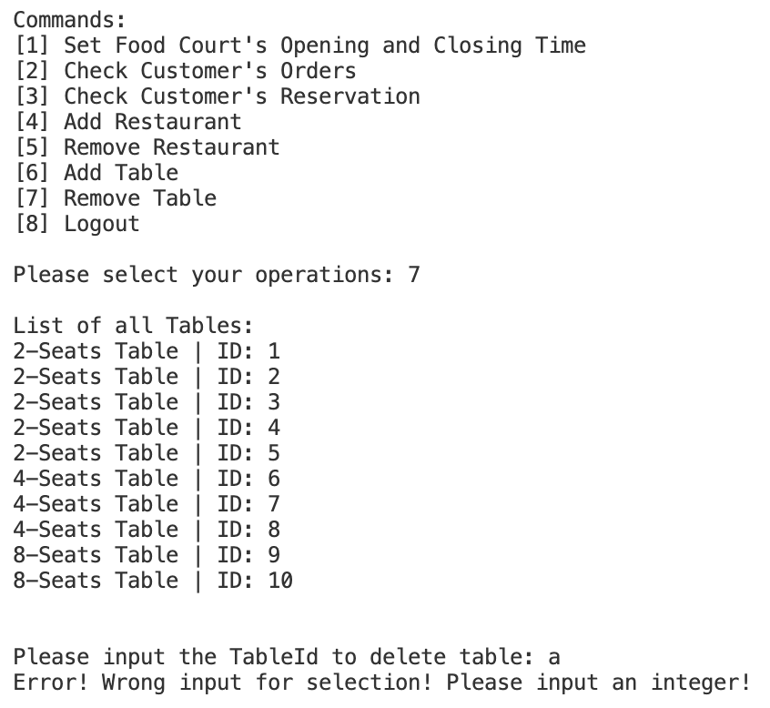

**5.3 Sample Bug Report**

**Issue #C1**

|  |  |
| --- | --- |
| **Title:** | **Invalid Integer input in “Please choose the restaurant to order:”** |
| **Reported Date:** | 11 November 2022 |
| **Severity Level:** | **Minor** |
| **Module:** | CommandCustomerDineIn |
| **Assigned To:** | **CHENG Yin** |
| **Status:** | Resolved |
| **Problem Description:**  Text  Description automatically generated  Should output “Please choose the restaurant to order:” instead of terminating the program. | |
| **Steps to reproduce the bug:**  Text  Description automatically generated   1. Login as Customers. 2. Choose to dine in. 3. Enter the number of people. 4. Choose to walk in. 5. Enter “5” under the above situation. | |
| **Comment By Developer:**  Added a Try-Catch block to catch the IndexOutOfBoundsException and looped to another round of asking, “Please choose the restaurant to order:”  if the customer input an invalid input. | |

**Issue #M1**

|  |  |
| --- | --- |
| **Title:** | **Error in Delete Dish module when the menu is empty** |
| **Reported Date:** | 13 November 2022 |
| **Severity Level:** | **Minor** |
| **Module:** | Merchants, CommandMerchantModifyMenu |
| **Assigned To:** | **CHENG Yin** |
| **Status:** | Resolved |
| **Problem Description:**  Text, letter  Description automatically generated  Should output “Menu is empty, please try again” instead of outputting an error. | |
| **Steps to reproduce the bug:**  Text  Description automatically generated   1. Login as Merchants. 2. Choose to “[1] Modify Menu”. 3. Choose to Delete Dish as the above figure shows. 4. Continue the previous step until the menu is empty. 5. Then choose to Delete Dish as the above figure shows. | |
| **Comment By Developer:**  Add two if clauses to restrict the Merchants.removeDish() to be executed only when the restaurant's menu is not empty. | |

End of Report